April 28, 2021

Team 6

CHE0613 Systems Engineering II: Process Design

University of Pittsburgh

Matthew Green 

Logan Dailey 

Bret Leydig 

Jacob Goodwin 

Eli Wissenbach 

Kimberly Xue 

Nick Shi 

Timothy Pickard 

Joseph “Brett” Mallon 

**CHE0613 Design Project IV**

**Team 6**

**Logan Dailey, Matthew Green, Jacob Goodwin, Bret Leydig, Timothy Pickard, Nick Shi, Eli Wissenbach, Kimberly Xue, Joseph Mallon**

**Dr. Bayles**

**Production of Ethylene by Catalytic Dehydration of Ethanol**

**April 28th, 2021**

**Nomenclature**

Symbol Definition Units

$H_{f,l}$ Liquid Heat of Formation kcal/mol

R Gas Constant psi*ft3*lb/mol-R

Vflow Volumetric Flow Rate ft3/hr

Pa Pressure/Partial Pressure psiA

SA Surface Area ft2

L Length of equipment ft and/or in

S Entropy cal/K

k Heat Capacity Ratio ---

ƞ Polytropic Efficiency ---

µ Impellar Diameter in

H Polytropic Head ft*lbf/lbm

Ua Acoustic Velocity ft/s

Vs Specific Volume ft3/lbm

Z Compressibility Ratio ---

W Specific Volumetric Flow ---

${-r}_{A}$ Reaction Rate $[\frac{mol}{s g_{cat}}]$

kn Kinetic Parameters ---

X Reaction Conversion ---

ρ Density ton/cuft

Fa Molar Flow Rate mol/hr

Β0 Ergun Equation Parameter ---

ɛ Void Fraction ---

g Gravity lbmft/hr2lbf

u Gas Viscosity lbm/fthr

G Superficial Mass Flux lbm/ft2hr

Dp Particle Diameter ft

Vr Volume ft3

Hv Heat of Vaporization kcal/mol

vperm Vapor Permissable Velocity ft/hr

Kv Vapor Velocity Design Factor ft/sec

AD Cross Sectional Area ft2

Ccat Cost of Catalyst $USD

Wreacto Weight of Reactor lbm

E Weld Efficiency ---

**Executive Summary**

This report proposes a plant design to produce ethylene via the dehydration of ethanol. Ethylene is mainly used as the starting material for various industrial processes, particularly polyethylene, ethylene oxide, and ethylene glycol [1]. Demand for ethylene has been steadily increasing, with ethylene oxide being the eighth most produced chemical in the world as of 2016, and polyethylene variants accounting for three of the five most used plastics globally [2] [3]. Ethylene oxide is used both as antifreeze and as the starting material to produce ethylene glycol, while polyethylene and ethylene glycol are important materials in the production of packaging and textiles. The plant is designed to produce 854,544,000 pounds annually of ethylene to control a 1% share of the United States ethylene market.

To meet industry standards, it was determined that the ethylene would be purified to 99.6% by mass. This high purity is achieved through two parallel reactors followed by two stages of flash separations and a recycle stream. In the process, the feed consists of 95% ethanol and 5% water with both being in liquid states. The feed stream enters a fired heater which produces the ideal conditions for the reaction. The feed stream is then split evenly into two new streams which enter two reactors. The reactors are in a parallel system and utilize a Zeolite Socony Mobil–5 catalyst or H-ZSM5. The zeolite catalyst is used to allow carbocation isomerization as it is very acidic and attracts a positive hydrogen atom from the ethanol. H-ZSM5 creates a high selectivity for the desired ethylene product. Although there is high selectivity, there are side reactions within the reactors that produce diethyl ether, acetaldehyde, methane, acetic acid, and ethane [4]. For simplicity, only diethyl ether is included in the process analysis as it is the most prevalent side reaction. After the reaction occurs the products go through a separation train. Diethyl ether emerges as a liquid from the reactor and is a clear color with a sweet odor [5]. Diethyl ether is known to be flammable and cause eye irritation or drowsiness. Ethylene, the main product, emerges as a liquid from the reactor that is colorless with a sweet odor [6]. Ethylene is extremely flammable and can cause suffocation in a gaseous form.

As the shape of the plant came to be a process flow diagram was created to express each of the stream flows and pieces of equipment in the process. To do this mass balances were performed on each piece of equipment and the process as a whole. To fully design each piece of equipment energy balances were also performed. These energy and mass balances allowed for the equipment pieces to be properly sized. Now that equipment was properly sized the installation and equipment cost to build them were determined. This data and specifics of building material, operating conditions, and sizes are all summarized in equipment data sheets that were created.

As determined that plant would be built in the location of San Antonio, Texas, and an alternate location of in the country of Panama plots of land could be determined based on the size of plant. A plant blueprint or plant layout was also produced based on safety regulations and equipment sizing. This plant layout helped determine the size of land needed as land needed to be large enough to accommodate offices and equipment spacing according to regulations. It was determined that 225 acres was needed to build the plant. This comes at cost of $1,938,000 for the Texas location and $1,725,000 for the alternate Panama location.

As the designed plant will be operating for 8000 hours per year and the production rate of ethylene is 106,818 pounds per hour the plants revenue of $2.327 billion per year was determined. This calculation is covered in depth in the Projected Market Share section. This section also covers the approximation of the 1% of the US market share that the designed plant would control. Economics of the designed plant is also presented in the raw materials, cost, and prices section. This section covers in depth the cost of the feed streams and sums the costs of all equipment. With this info the overall cost of the plants first year of operation is tallied as the direct manufacturing costs, general expenses, and fixed manufacturing come to $550,096,282.53 for the Texas location and $548,461,821.35 for Panama location. After establishing raw materials, revenue and costs a full economic analysis was performed.

The economic analysis investigated the total capital investment, discounted payback period, as well as the most important aspect, profitability. Two different methods were used to determine discounted cumulative cash flows. After cumulative cash flows were determined it was concluded the payback period was soon after year two ended. Profitability was reached around the middle of year three of operation for all investigated discount rates, and both depreciation methods. It is clear that the plant will be a desired investment because it is profitable shortly into the project life span, and the future value of the plant is substantially greater than if the total capital investment was invested in a regular fund.

Relevant safety concerns and design issues were also considered as some chemicals used in this plant design are hazardous. This relevant safety concerns and design issues section also covers measures put in place because of inherent dangers of the plants operating conditions and mitigative safety measures in place and responses to prevent a disastrous event and steps in place if one did occur. A sensitivity analysis was also performed in Aspen Plus V10 on flash tanks V201 and V202 to test the effects of temperature and pressure on the separation capabilities in the simulation and optimization results section. Process control is comprised of the several systems that measure parameters of inlet and outlet streams, the compositions of the streams, and prevent any deviation from the quality standards. In each plant, process control is put into place for every major piece of equipment. For this plant, a singular flash tank process control design was considered for implementation and is covered in the process and instrumentation diagram section.

Social, global, and environmental impacts have also been laid out for both locations as they both have different regulations and challenges that come along with them. On a global level, the United States is the sole exporter of ethylene in North America, with Texas being responsible for producing the majority of ethylene. The domestic site selected was in San Antonio because it is the second most populated city in Texas. There is a lot of commercial zoned land that is big enough to contain a chemical plant. Panama has access to the oceans with the Panama Canal, and it is just starting to engage in ethylene trade. By building a plant, the global trade in ethylene would increase, as ethylene is a very versatile chemical and is high demand due to its use in common items such as plastic.

Environmental impacts were also considered when deciding where to build the plants. Texas and Panama both experience severe weather. The proper precautions must be taken in order to avoid any possible disasters due to any destruction or loss of property, which is especially important due to climate change. Spills are also a potential hazard that the plant can pose. By leaking into bodies of water, aquatic life can be harmed due to ethanol and the degradation of ethylene into formaldehyde. In order to combat this, different approaches were taken. By using an environmentally friendly catalyst, H-ZSM5, the process would require less maintenance and reduce waste. Process fluids would also be preheated by pairing HX101 and HX102 with P101 before it enters H101 so that there would be less flue gas used. By implementing biogas from plant and animal waste, there would be fewer emissions and less waste buildup.

The severe weather of the areas could give rise to social anxieties due to the construction of the ethylene plant. A disaster caused by the plant could potentially make people distrust in its existence and maybe even cause people to protest the construction. By taking the proper safety precautions, people’s fears could be assuaged. Safety can also be improved by having the plant provide healthcare for their employees. Because Panama is still developing, there is the possibility of bridging the gender equality gap with the availability of work.



**Table of Contents**

**1.0 Introduction…………………………………………………………..………………………1**

**2.0 Technical Background………………………………………………………………..……...5**

**3.0 Process Description………………………………………………………………..…………6**

**4.0 Raw Materials, Cost, Prices…………………………..……………………………………..7**

**5.0 Projected Market Share……………………………………………………………………13**

**6.0 Process Flow Diagram……………………………………………..……………………….15**

**7.0 Material Balance…………………………………………………………………..………..40**

**8.0 Energy Balance…………………………………………………..………………………….40**

**9.0 Equipment List and Design Details………………………………………………..………16**

9.1 *Flash Tank Design***………………………………………………………………….12**

9.2 *Reactor Design***………......……..…………………….…………………………….12**

9.3 *Fired Heater Design***………………………..……………..……………………….12**

9.4 *Compressor Design***………………………………………..……………………….12**

9.5.1 *Heat Exchanger Design H101***………………...………………………………….12**

9.5.2 *Heat Exchanger Design H102***……………………...…………………………….12**

9.6 *Distillation Column Design***………………...………...…………………………….12**

**10.0 Relevant Safety Concerns and Design Issues……………………………………………42**

**11.0 Simulation and Optimization Results……………………………………………………44**

**12.0 Process and Instrumentation Diagram…………………………………………………..44**

**13.0 Site Selection……………………………………………………………………………….44**

**14.0 Relevant Environmental Regulations……………………………………………………48**

**15.0 Summary…………………………………………………………………………………...49**

**16.0 References………………………………………………………………………………….51**

**A.0 Appendices………………….………………………………………………………………58**

A.1 *Reaction Schemes***……………………………………………………………………………12**

A.1 *Sample Calculations***………………………………………………………………………...12**

A.1 *Equipment Data Sheets***……………………………………………………….**

**1.0 Introduction**

Ethylene, a double-bonded carbon chain, is used globally in various forms of polymer manufacturing. The polymers that are built from ethylene are then used to create consumer products. Polyethylene, polyethylene terephthalate, polyvinyl chloride, and polystyrene are a few chemical products that are derived from ethylene. These products have numerous industrial and commercial uses ranging from packaging, construction, electrical, and adhesives [1]. More specifically, polyvinyl chloride is used to produce common types of plumbing, polystyrene is used to make food packaging and polyethylene terephthalate is used as a coating for non-stick cooking pans.

Traditionally ethylene is produced by steam cracking of differing hydrocarbon feedstocks [4]. To manufacture ethylene in the process covered by this report, a dehydration reaction was utilized. The dehydration reaction was chosen to analyze as it is less complicated than the steam cracking process. The dehydration reaction also produces less pollutants than the cracking process. The dehydration reaction starts with a feed of ethanol and water which reacts to produce ethylene. Figure 1.1 displays a simple block flow diagram of the process. Many different catalysts were analyzed to add to the reaction process, but H-ZSM5 was chosen due to its high selectivity of ethylene. H-ZSM5 is an aluminosilicate zeolite with a high silica and low aluminum content. The catalyst promotes carbocation isomerization's as the aluminum components are very acidic. This allows a positively charged hydrogen atom to become. Thus, the dehydration of ethanol occurs. Although the catalyst mainly produces ethylene, there is an additional side reaction that was considered [7].

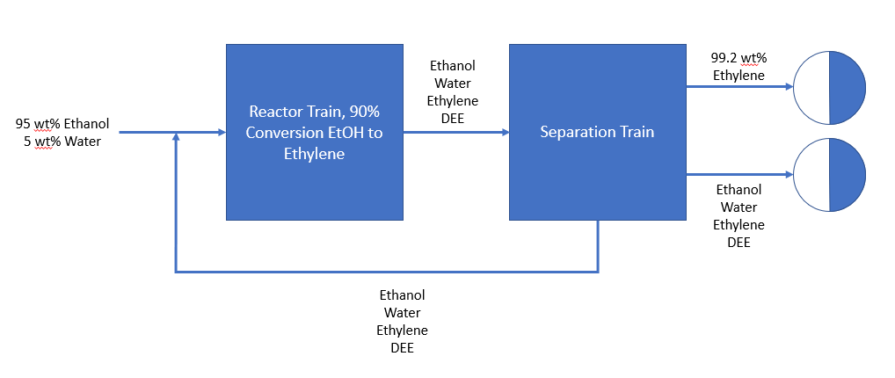**Figure 1.1** Block flow diagram of the proposed ethylene process

The dehydration reaction along with chemical structures are shown in Figure 1.2.

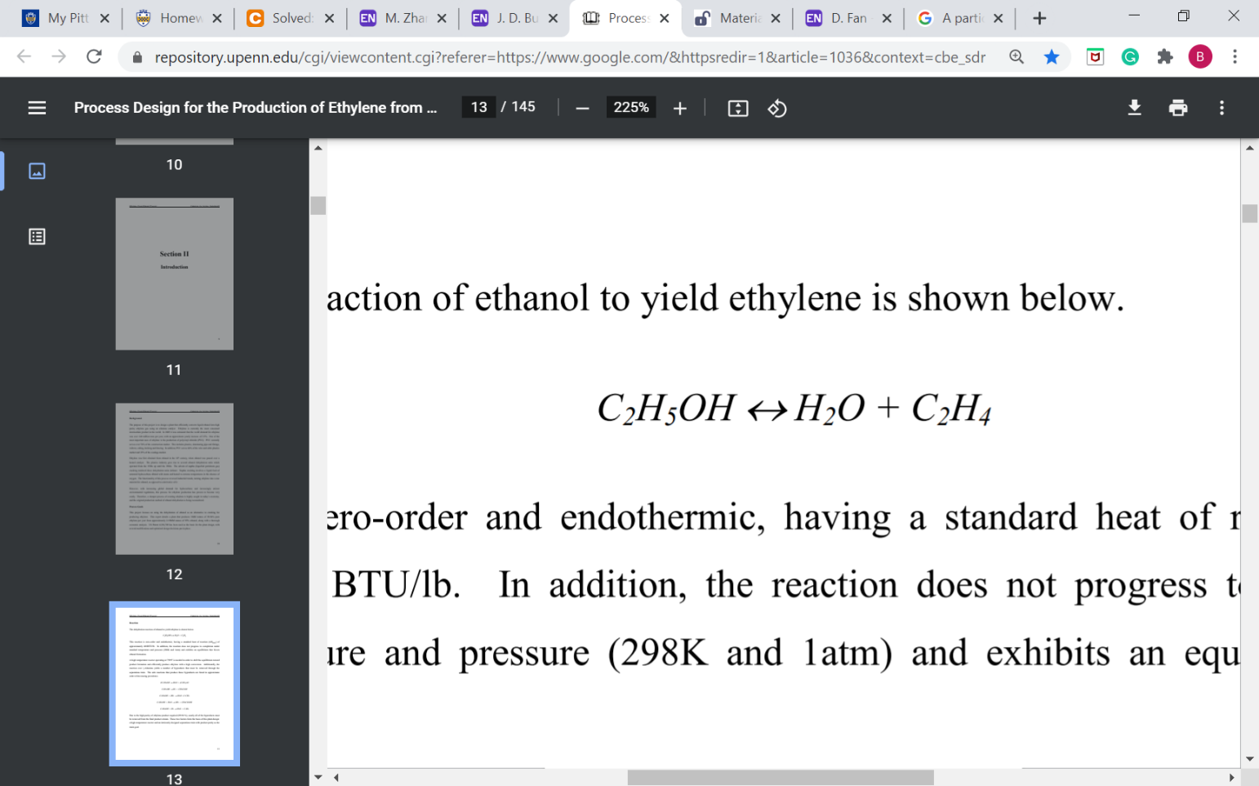

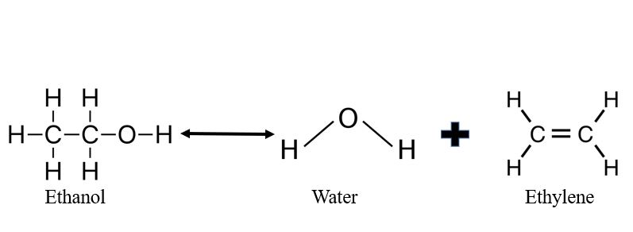

**Figure 1.2** Dehydration reaction of ethanol [8].

Generally, the dehydration of ethanol has numerous side reactions, but for the purpose of this design only one was considered. The side reaction that takes place is shown in Figure 1.3.

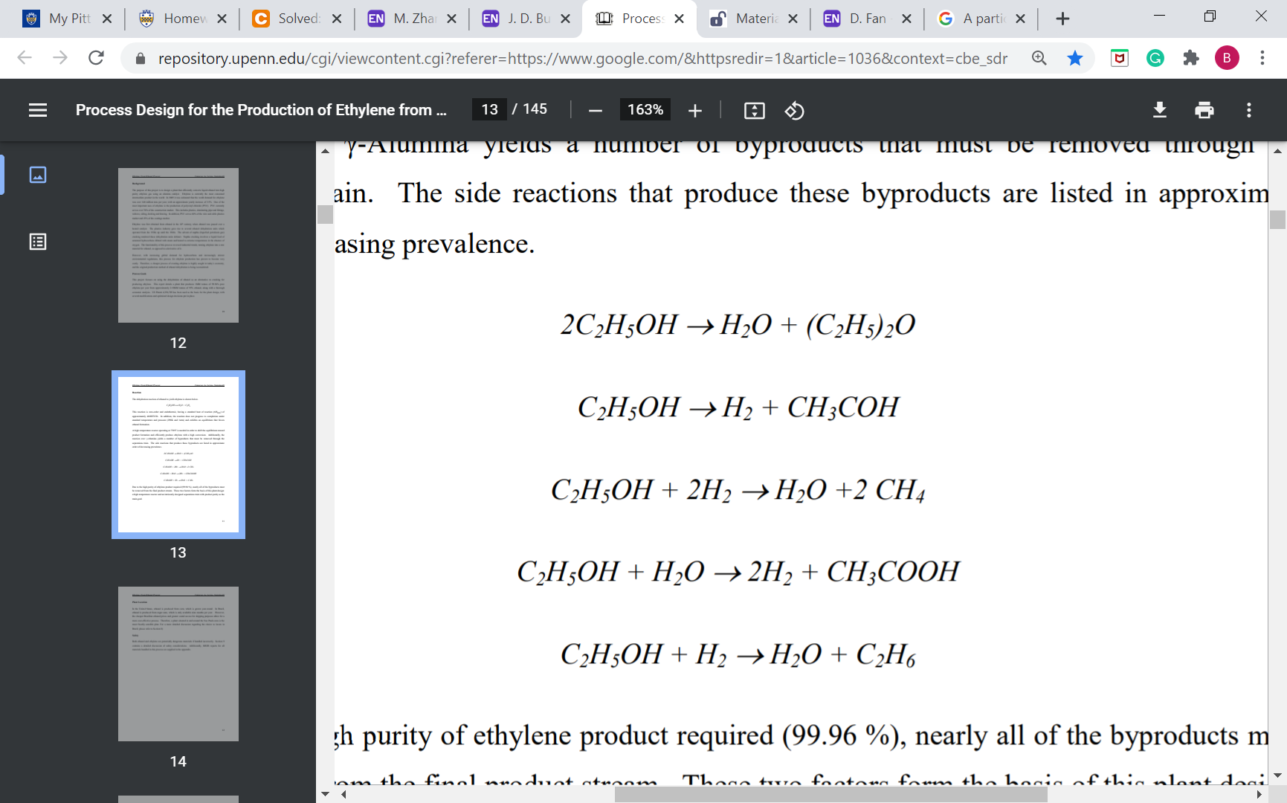

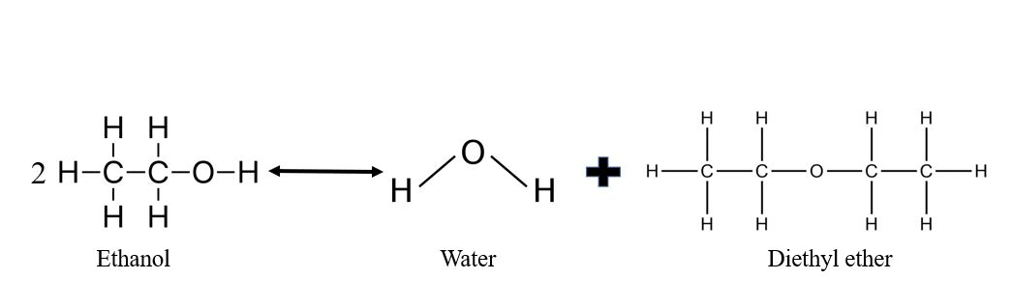

**Figure 1.3** Side reaction of ethanol to produce water and diethyl ether [8].

The feedstock in this process is maintained at ambient conditions. Tables 1.1, and 1.2 show physical properties of ethanol and water at the feed conditions. Each table also conveys relevant safety information.

**Table 1.1** Ethanol’s physical properties at ambient conditions [9].

|  |  |
| --- | --- |
| **Ethanol** |  |
| Molecular Weight | 46.07 g/mol |
| Appearance | Clear, colorless |
| Odor | Fragrant, alcohol |
| Phase | Liquid |
| Safety | Health Rating 2 – Materials that under emergency conditions can cause residual injury.  Fire Rating: 3 – Liquids and solids that can be ignited under almost all ambient temperature conditions.  Instability rating: 0 – Materials that in themselves are normally stable, even under fire conditions. |
| Boiling point | 172.76 °F |

**Table 1.2** Physical properties of water at ambient conditions [10].

|  |  |
| --- | --- |
| **Water** |  |
| Molecular weight | 18.02 g/mol |
| Appearance | Clear, colorless |
| Odor | Odorless |
| Phase | Liquid |
| Safety | Non-hazardous |
| Boiling Point | 212 °F |

The desired product and waste are produced at varying process conditions which dictates the phase of each component. For simplification, each chemical product is listed in Tables 1.3 and 1.4 which show the physical properties and safety data at ambient conditions.

**Table 1.3** Physical properties of ethylene at ambient conditions [11].

|  |  |
| --- | --- |
| **Ethylene** |  |
| Molecular weight | 28.05 g/mol |
| Appearance | Clear, colorless |
| Odor | Sweet, Olefinic |
| Phase | Gas |
| Safety | Health Rating: 2 – Materials that under emergency conditions can cause residual injury.  Fire Rating: 4 – Materials that rapidly or completely vaporize at atmospheric pressure and normal ambient temperature or that are readily dispersed in air and burn readily.  Instability rating: 2 – Materials that readily undergo violent chemical changes at elevated temperatures and pressures.   |  | | --- | | Specific: W - No water: Materials that react violently or explosively with water. | |
| Boiling Point | -154.66 °F |

**Table 1.4** Physical properties of diethyl-ether at ambient conditions [12].

|  |  |
| --- | --- |
| **Diethyl Ether** |  |
| Molecular weight | 74.12 g/mol |
| Appearance | Clear, colorless |
| Odor | Pungent, sweet |
| Phase | Liquid |
| Safety | Health Rating: 1 – Materials that, under emergency conditions, can cause significant irritation.  Fire Rating: 4 – Materials that rapidly or completely vaporize at atmospheric pressure and normal ambient temperature or that are readily dispersed in air and burn readily.  Instability rating: 1 – Materials that in themselves are normally stable but that can become unstable at elevated temperatures and pressures. |
| Boiling Point | 94.28 °F |

Throughout the entire process operating conditions change thus creating different phases of each chemical. The desired product, ethylene will leave the plant at a temperature of 32 °F and a pressure of 435.11 psia. Under these conditions the product stream consists entirely of vapor. There are two waste product streams which exist in the liquid phase. Ethanol, diethyl ether, water, and a small fraction of ethylene are all present in the waste streams.

1. **Technical background**

The reaction takes place in two separate parallel packed bed reactors. Each reactor is fed with an equivalent feedstock. Having the feedstock entering each reactor at 572 °F allows the reaction to reach 90% conversion of ethanol with 99.9% selectivity to ethylene.

The flash tanks are designed to purify the streams for the desired product by dropping the temperature and pressure low enough to allow ethylene to enter the vapor phase while leaving as much water, ethanol, and diethyl ether in the liquid phase. The top streams from both flash tanks are combined with the distillate stream of a distillation column that is designed to recover any ethylene that could not be flashed off. These streams are combined and stored away in spherical cryogenic storage tanks at -155 °F and ambient pressure.

To recover the unreacted ethanol, a distillation column was used to prevent as much water as possible from being recycled into the stream. The removed water and a small amount of ethanol, ethylene, and diethyl ether are then sent to waste storage tanks, while the distillate stream is combined with the feed stock before entering the fired heater.

1. **Process Description**

This plant described involves the dehydration of ethanol at a temperature of 572 °F and 630 psia. A common catalyst, H-ZSM5, is used in this plant although others can be selected. The desired reaction of this plant is shown in Equation 3.1.

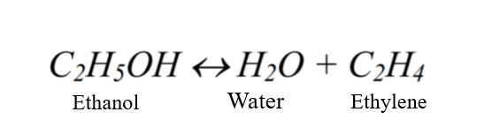

**Chemical Equation 3.1** Desired Dehydration of Ethanol Reaction [8]

Side reactions during ethylene production using H-ZSM5 can lead to undesired byproducts, including hydrogen, ether, acetaldehyde, acetic acid, methane, water, and ethane [8]. For simplification, this process will only focus on the side reaction that produces diethyl ether and water, shown in Equation 3.2.

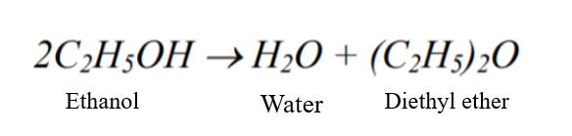

**Chemical Equation 3.2** Side Reaction of Ethanol to Water and Diethyl Ether [8]

Changing the reactor temperature or pressure can alter the selectivity and yield for the reaction. With the given conditions, a 90% conversion of ethanol and 99.9% selectivity towards ethylene exists. This is achieved by using two reactors with a series of flash separations. Two flash tanks are used post-reaction to obtain the design 99.6% mass purity of ethylene. The remaining water, ethanol, diethyl ether, and unseparated ethylene are sent through a series of distillation columns to recover any ethylene that was not removed from the flash tanks and recycle ethanol back into the system.

The plant produces 106,819 pounds of 99.6% ethylene per hour, and the plant operates 8000 hours per year, resulting in a yearly production of 427,275 tons of ethylene.

1. **Raw Materials, Costs, and Prices**

The raw materials, costs and prices were analyzed at two separate locations. The first location, San Antonio, Texas where the plant will be built. The second location in Panama was analyzed to show an economic comparison in a different region. Raw material costs were similar for each site. The proposed plant design consists of two materials as the main feedstock, ethanol and water. To aid the reaction another material, H-ZSM5, will be implemented. The raw cost of 95% Ethanol is 1.8 USD per gallon [13]. Pricing was calculated from projected purchases in bulk at the trading price of ethanol in the US. Presumably, the trading price is very similar to the purchase price as would be attained from a bulk order from large chemical wholesalers that provide lower mark ups for high quantity purchases. The feed composition flowing into the plant contains 27436.5 gallons of ethanol per hour and 1129.3 gallons of water per hour. Tapping into the main city water lines will be the source for the water feedstock. This price can vary and fluctuate depending on location. This plant is projected to be in operation for 8,000 hours every year which equates to a total ethanol cost of 395,085,941.81 USD per year. Calculations 4.1 further explains the derivation of raw material cost.

Conversion to USD/year:

27436.5 gal/hr * 1.8 USD/gal * 8000 hr/year = 395,085,941.81 USD/year (4.1)

Another key material in the main feedstock is water. The water will react with the ethanol producing the desired product, ethylene. Water pricing will vary based on location of the plant. The design proposal will tap into city water lines which will allow for a larger quantity of water to be brought to the plant. Projected water cost was calculated using the average cost in the state of Texas, 5,000 gallons for $35.19 or 0.0079 USD per gallon [14]. The feedstock water flow is 1129.3 gallons of water per hour. As stated before, this plant will be in operation for 8000 hours per year, therefore the total cost of water is 71,370.59 USD per year for the Texas location. Calculations 4.2 further explains the derivation of raw material costs. Water costs for Panama are less as 0.0011 USD per gallon and calculations 4.3 derive the yearly costs of 9,937.24 USD per year for the Panama location.

Conversion to USD/year Texas location:

1129.3 gal/hr * .0079 USD/gal * 8000 hr/year = 71,370.59 USD/year (4.2)

Conversion to USD/year Panama location:

1129.3 gal/hr * 0.0011USD/gal * 8000 hr/year = 9,937.24 USD/year (4.3)

To aid the reaction a highly selective catalyst will be utilized. H-ZSM5 will be loaded in each reactor. Currently, the price of H-ZSM5 to fill each reactor is 115,294 USD. There are two reactors in the process thus equating to a cost of 230,588 USD. It will be in best interest to partner with a large producer of the catalyst to decrease the price as much as possible. Another added cost is the replacement of the H-ZSM5 as all the catalyst must be removed and replaced every 90 days that the plant is in operation [8]. This means the H-ZSM5 must be replaced 4 times every year resulting in a yearly catalyst cost of 922,352 USD per year.

Catalyst cost USD/year :

115,294 USD/reactor * 4 number of replacements/years * 2 reactors = 922,352 USD per year (4.4)

Table 4.1 summarizes the total raw material cost for the operation. The total cost for one year of operation, is 396,079,667USD per year in the Texas plant location. Table 4.2 summarizes the total raw material cost for the operation and the total cost for one year of operation is 396,018,234 USD per year in the Panama location.

**Table 4.1** Raw material cost Texas

|  |  |
| --- | --- |
| **Material** | **Cost (USD/YR)** |
| Ethanol | $395,085,941.81 |
| Water | $71,370.59 |
| H-ZSM5 | $922,352 |
| **Total** | **$396,079,667** |

**Table 4.2** Raw material cost Panama

|  |  |
| --- | --- |
| **Material** | **Cost (USD/YR)** |
| Ethanol | $395,085,941.81 |
| Water | $9,937.24 |
| H-ZSM5 | $922,352 |
| **Total** | **$396,018,234** |

After designing the chemical process which defined, raw materials, flow rates, and equipment, a full economic analysis can be performed. Economic analysis is extremely important when investment of large amounts of money is taking place. The analysis is used to determine whether the project can be successful if a company would proceed forward. At this point the estimation of costs and profit is in the range of + 25 % to under 15%. This estimation is called preliminary design or a scope estimate. A scope estimate includes a PFD, vessel design, utilities, and plant layout, all of which has been discussed. Proceeding with the economic analysis, both site locations were compared.

To determine profitability major costs must be considered and estimated. There are three main category's that contribute to cost every operating year. These include, direct manufacturing costs, fixed manufacturing costs and general expenses. Other considerations include the total capital investment. First, consider the direct manufacturing costs.

A major cost to this design process is the fixed capital investment (FCI). FCI is calculated from the cost of all the equipment in the plant. Not only does the FCI contain the equipment cost, it also includes the installation costs of each piece. Equipment data sheets in appendix 3 provide more detail on each piece. In total the fixed capital investment required for this plant equates to 197,030,595.44 USD.

Other costs associated with direct manufacturing include waste treatment, raw materials, utilities, labor, and supplies. Table 4.3 provides a summary of the directed manufacturing costs for the Texas plant location. Table 4.4 provides comparison to the alternate location of Panama. The total direct manufacturing cost is 429,601,613.20 USD for the Texas location and 428,728,357.23 USD for the Panama location.

**Table 4.3** Directed manufacturing costs for the Texas plant location

|  |  |
| --- | --- |
| **Description** | **Value (USD/YR)** |
| Raw Materials | $396,079,666.63 |
| Waste treatment | $51,902.90 |
| Utilities | $2,734,560.00 |
| Operating labor | $962,000.00 |
| Direct supervisory and clerical labor | $168,350.00 |
| Maintenance | $11,821,835.73 |
| Operating supplies | $1,773,275.36 |
| Lab supplies | $144,300.00 |
| Patents + loyalties | $15,860,913.20 |
| **Total** | **$429,601,613.20** |

**Table 4.4** Direct manufacturing costs for the Panama plant location

|  |  |
| --- | --- |
| **Description** | **Value (USD/ First YR)** |
| Raw Materials | $396,018,233.72 |
| Waste treatment | $51,902.90 |
| Utilities | $2,734,560.00 |
| Operating labor | $390,000.00 |
| Direct supervisory and clerical labor | $68,250.00 |
| Maintenance | $11,821,835.73 |
| operating supplies | $1,773,275.36 |
| Lab supplies | $58,500.00 |
| Patents + loyalties | $15,811,799.52 |
| **Total** | **$428,728,357.23** |

To provide further insight, the main difference between the two site locations is the operating labor costs. The operating labor costs in Panama is about 60% lower than Texas. Another key difference is the cost is the price of water. In Texas, the price of water is 0.0079 USD per gallon while in Panama is cost only 0.0011 USD per gallon. Although these differences are major with respective counterparts, the overall direct manufacturing costs differ by only 873,255.97 USD.

Continuing, fixed manufacturing costs were calculated. Fixed manufacturing includes analyzing depreciation, taxes and insurance, as well as plant overhead costs. At this point the depreciation is only an estimate. When profitability is analyzed, depreciation will be taken into full consideration. Table 4.5 contains the economics of fixed manufacturing at the Texas plant location. Table 4.6 provides the costs at the Panama location.

**Table 4.5** Fixed manufacturing at the Texas plant location

|  |  |
| --- | --- |
| **Description** | **Value (USD/YR)** |
| Depreciation | $19,703,059.54 |
| Taxes and insurance | $6,304,979.05 |
| Plant overhead | $7,771,311.44 |
| **Total** | **$33,779,350.03** |

**Table 4.6** Fixed manufacturing at the Panama plant location

|  |  |
| --- | --- |
| **Description** | **Value (USD/YR)** |
| Depreciation | $19,703,059.54 |
| Taxes and Insurance | $6,304,979.05 |
| Plant overhead | $7,368,051.44 |
| **Total** | **$33,376,090.03** |

As seen by tables 4.5 and 4.6 the fixed manufacturing costs only differ by about 400 thousand USD.

The last costs that were analyzed and compared are the general expenses of the plant. The general expenses include administration, distribution and selling, as well as money budgeted for research and development. Tables 4.7 and 4.8 summarizes the general expenses for each plant location.

**Tables 4.7** General expenses for Texas plant location

|  |  |
| --- | --- |
| **Description** | **Value (USD/YR)** |
| Administration | $1,942,827.86 |
| Distribution and selling cost | $58,156,681.72 |
| Research and Development | $26,434,855.33 |
| **Total** | **$86,534,364.90** |

**Tables 4.8** General expenses for Panama plant location

|  |  |
| --- | --- |
| **Description** | **Value (USD/YR)** |
| Administration | $1,842,012.86 |
| Distribution and selling cost | $57,976,598.24 |
| Research and Development | $26,352,999.20 |
| **Total** | **$86,171,610.30** |

Adding up all three of the operating costs concludes the plant will spend 549,910,518.75 USD for every year it is in operation in Texas location and 548,276,057.57 USD in Panama location. Table 4.9 provides a summary of the totals for each plant location.

**Tables 4.9** Texas and Panama expense totals

|  |  |  |
| --- | --- | --- |
| **Description** | **Texas Value (USD/YR)** | **Panama Value (USD/YR)** |
| Directed Manufacturing | $429,601,613.20 | $428,728,357.23 |
| Fixed manufacturing | $33,890,728.74 | $33,376,090.03 |
| General Expenses | $86,171,610.11 | $86,171,610.30 |
| **Total** | **$550,096,282.53** | **$548,276,057.56** |

1. **Projected Market Share**

The global production of ethylene in 2020 was just above 155.1 million metric tons. The market value of the same product in 2019 was estimated to be 162.50 billion USD [16]. The United States contributed to 27% percent of the worldwide market. This equates to upwards of 41.7 million metric tons. Based on the current global value, the US production corresponds to a value of 43.875 billion USD.

To gain any market share of ethylene is a challenge as large companies such as Saudi Basic Industries Corporation (SABIC), The Dow Chemical Company, Exxon Mobil Corporation, China Petroleum & Chemical Corporation (Sinopec Corporation), and Chevron Phillips Chemical Company LLC, control the majority of the production [17]. Although reaching significant control will be near impossible, obtaining a small percent can be financially rewarding. With these statistics, the plant is designed to produce around 854,544,000 pounds or 387,614.6 metric tons annually of ethylene. Achieving this will result in earning 1% of the United States market. The price per kilogram of ethylene at the desired purity level is $5.99 USD per kg if purchased in bulk [18]. Meaning that the projected revenue of the plant is 2.327 billion USD per year. Table 5.1 provides a summary of the projected revenue from the sale of ethylene product. Furthermore, calculations 5.1 and 5.2 explains the derivation of the product value of ethylene.

**Table 5.1** Projected revenue

|  |  |  |  |
| --- | --- | --- | --- |
| **Material** | **Production (lb/HR)** | **USD/KG** | **USD/YR** |
| Ethylene | 106,818 | $5.99 | $2.327 billion |

106,818 lb/hr * (1kg/2.2lbs) * 5.99 USD/kg = $290,836.28 USD/hr

(5.1)

$290,836.28 USD/hr * 8000 hrs = 2.327 billion USD/year

(5.2)

Notice that this value is gross revenue and not projected profit as initial costs of plant, operational costs are not considered. A more detailed economic analysis will be provided in the latter, after the design, site selection, impacts were considered.

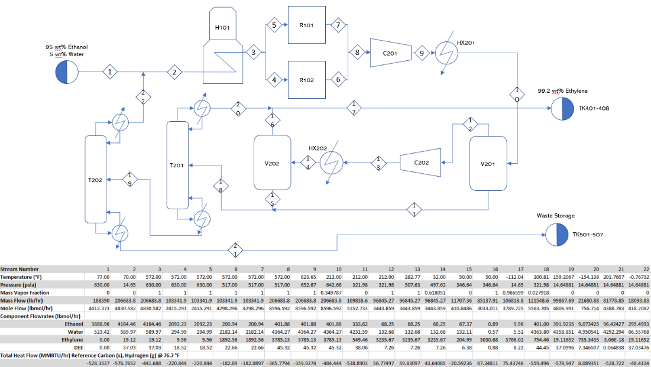**6.0 Process Flow Diagram**

Beginning at stream 1, a 95 wt% ethanol and 5 wt% water stream is combined with the distillate stream 22 from distillation column T202 to form stream 2. Stream 2 enters fired heater H101 and leaves through stream 3, where the exiting stream splits into streams 4 and 5 and enter the parallel packed bed reactors R102 and R101 respectively. From R102 and R101, streams 6 and 7 recombine into stream 8 and are sent to the separation train. Stream 8 enters compressor C201 and leaves through stream 9 where it then enters the heat exchanger HX201. Stream 10 leaves HX201 and is sent to flash tank V201. Stream 12, the top stream from V201, is then sent to compressor C202, where it leaves through stream 13 and enters the heat exchanger HX202. From HX202, stream 14 enters the second flash tank V202. Stream 15 from the bottom of V202 is combined with stream 11, the bottom stream from V201, to form stream 18. Stream 18 is sent into the distillation column T201. From T201, the distillate stream 20 is combined with stream 16 coming out the top of V202 to form stream 17, where is it sent to the product storage tanks TK401-408. From the bottom of T201, stream 19 is sent into the second distillation column T202. From the bottom of T202, stream 21 is sent to waste storage TK501-507.

1. **Material Balance**

The following mass balances were performed to verify that our plant is not violating the law of conservation of mass.

*Stream 2 Mass Balance*

**Table 7.1** Stream 2 Mass Balance Calculation

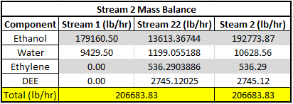

*R101 Mass Balance*

**Table 7.2** R101 Mass Balance Calculation

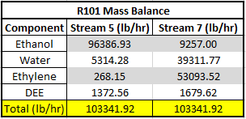

*R101 Mass Balance*

**Table 7.3** R102 Mass Balance Calculation

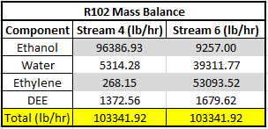

*V201 Mass Balance*

**Table 7.4** V201 Mass Balance Calculation

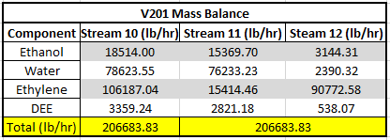

*V202 Mass Balance*

**Table 7.5** V202 Mass Balance Calculation

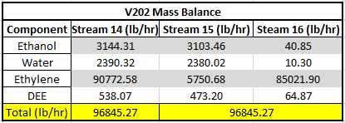

*T201 Mass Balance*

**Table 7.6** T201 Mass Balance Calculation

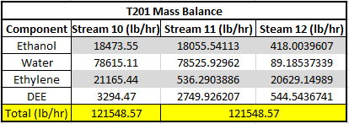

*T202 Mass Balance*

**Table 7.7** T202 Mass Balance Calculation

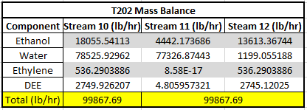

1. **Energy Balance**

The total heat flow for each stream in the ethylene process was calculated using literature thermodynamic data found in Tables 8.1 and 8.2 for each component within each stream. Final heat flow data can be found in the process flow diagram in Figure 6.1.

**Table 8.1** Thermodynamic Data [20] [21] [22] [23]

**Boiling Points, Heats of Formation, and Heats of Vaporization for Gases**

|  |  |  |  |
| --- | --- | --- | --- |
| Component | Heat of Formation (BTU/lbmol) | Heat of Vaporization (BTU/lbmol) | Boiling Point (F)/Melting Point (F) |
| Ethanol | -100800e+05 | 16636 | 173/-173.4 |
| Water | -104200e+05 | 17591 | 212/32 |
| Diethyl-ether | 3091 | 12500 | 93.9/-177.3 |
| Ethylene | 22591 | 5864 | -155/-272.6 |

**Table 8.2** Heat Capacity Coefficients [24]

**Heat Capacity Coefficients of Reactant and Product Gases**

|  |  |  |  |  |
| --- | --- | --- | --- | --- |
| Component | A | B | C | D |
| Ethanol | 4.396 | 0.628E-03 | 5.546E+05 | -7.024E+08 |
| Water | 4.395 | -4.186E+03 | 1.405E+05 | -1.564E+08 |
| Diethyl ether | 4.618 | 37.492E+03 | -1.87E+05 | 1.316E+08 |
| Ethylene | 4.221 | -8.782E+03 | 5.795E+05 | -6.729E+08 |

To calculate the heat flow of each component in the liquid streams, the heat of formations were added to the changes in enthalpy from temperature and pressure effects as seen in equation 8.1.

$Heat Flow=H_{f,g}+ R*\int_{T_{ref}}^{T}{A+BT+CT^{2}+DT^{3}dt}$ +VΔP (8.1)

Last, the contribution of heat flow from the vapor streams was calculated similarly to those of liquids using heats of vaporization as seen in equation 8.2 and both in conjunction with one another as in equation 8.3 when changing phases. A sample energy calculation can be found in Appendix II

$Heat Flow=H_{v,g}+ R*\int_{T_{ref}}^{T}{A+BT+CT^{2}+DT^{3}dt }$ (8.2)

$Heat Flow=H_{f,g}+R*\int_{T_{ref}}^{T_{B}}{A+BT+CT^{2}+DT^{3}dt}+H_{v,g}+R*\int_{T_{B}}^{T}{A+BT+CT^{2}+DT^{3}dt}$ (8.3)

1. **Equipment List and Design Details**

The ethylene plant will operate using the following major equipment:

* One fired heater (H101)
* Two catalytic reactors (R101, R102)
* Two compressors (C201, C102)
* Two heat exchangers (HX101, HX102)
* Two flash tanks (V201, V202)
* Two distillation columns (T201,T202)

*9.1 Flash Tank Design*

Two vertical flash tanks were designed for this process in order to separate contaminants from the product ethylene stream and achieve the desired purity of 99.2 wt% ethylene. The optimum operating conditions were determined by performing a sensitivity analysis about each flash tank. These were conducted in Aspen Plus, varying both temperature and pressure in order to select the best possible conditions for separation, and are tabulated below in Table 9.1.1.

**Table 9.1.1** Operating Conditions for Flash Tank Design

|  |  |  |
| --- | --- | --- |
| **Operating Condition** | **V201** | **V202** |
| **Pressure [psia]** | 321.98 | 346.64 |
| **Temperature [oF]** | 212.0 | 50.0 |

After the operating conditions were determined, the flash tanks were designed using the method proposed by F.L. Evans in 1980 and presented by Couper (2012). This is a stepwise method used to determine all design variables for a flash tank, mainly height and diameter as shown in Figure 9.1.1.

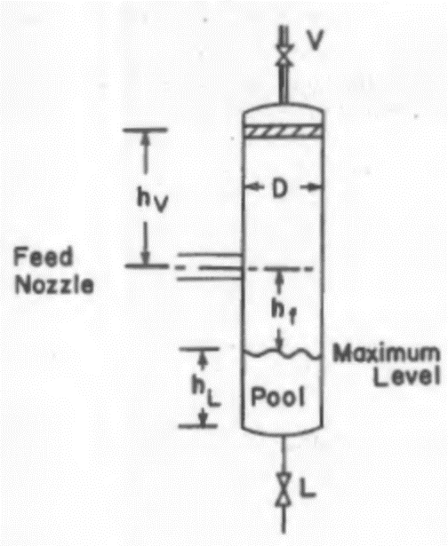

**Figure 9.1.1** Schematic of a Flash Tank with Design Variables

In the above figure, the height is accounted for in three sections: vapor (hv), feed line (hf), and liquid pool height (hL), and D represents the diameter.

The first step in the design using Evans’ method is to determine the vapor-liquid separation factor. This is calculated using the mass flow rates of the liquid and vapor components, represented by *m* in the following equation and denoted *l* for the liquid stream and *v* for the vapor stream. The ratio between these flow rates is combined with the root of the ratio of each streams average densities to obtain the separation factor.

$Separation Factor: \frac{m_{l}}{m_{v}}\sqrt{\frac{ρ_{v}}{ρ_{l}}}$*(Equation 9.1.1)*

In order to calculate the average densities of each stream, it was assumed (1): The vapor phase behaves as an ideal gas, and (2) The liquid phase is incompressible and therefore volume is additive. Using these assumptions, Equations below were used to calculate the average densities, given the composition of each stream from Aspen Plus.

$ρ_{l}=\sum_{i}{x_{i}*ρ_{i}}$ (Equation 9.1.2)

$ρ_{v}=\frac{P}{RT}\sum_{i}{y_{i}*{MW}_{i}}$ (Equation 9.1.3)

Here, *xi* represents the mass fraction of component *i* in the liquid stream and is multiplied with that component’s density. For the vapor density, the ideal gas law is used with the flash tank operating conditions, where *yi* represents the mole fraction of component *i* in the vapor stream, and *MWi* is that compound’s molecular weight. Once calculated, the separation factor may be used to determine the vapor velocity design factor (Kv) from analysis of Figure 9.1.2. The x-axis displays values of the separation factor, while the y-axis displays Kv, in ft/sec. Determined values for each flash tank can be found in Table 9.1.2.

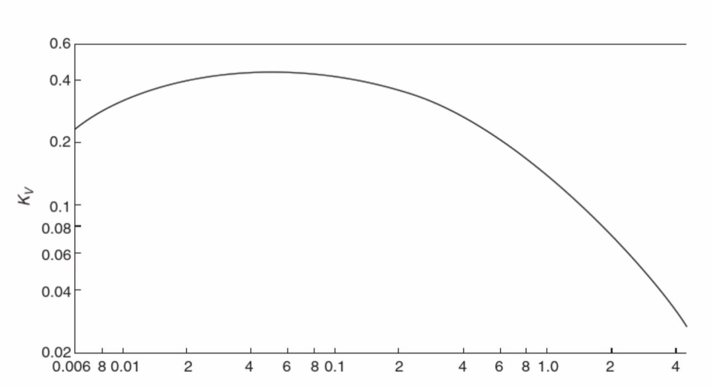

**Figure 9.1.2** Kv versus Vapor-Liquid Separation Factor

**Table 9.1.2** Average Densities, Separation Factors, and Kv Values for each Flash Tank

|  |  |  |  |  |
| --- | --- | --- | --- | --- |
| **Tank** | **rl [lb/ft3]** | **rv [lb/ft3]** | **Separation Factor** | **Kv [ft/sec]** |
| **V201** | 56.28 | 1.26 | 0.17 | 0.35 |
| **V202** | 44.88 | 1.78 | 0.03 | 0.38 |

The second step after obtaining the Kv values for each tank is to determine the permissible vapor velocity (vperm)within the tank. Finding the permissible velocity allows us to begin sizing the tank by analyzing the volumetric flowrates of the liquid and vapor streams, and the corresponding velocity through a certain cross-sectional area. Thus, as presented by Couper (2012), the diameter of the flash tank can be determined through the following set of calculations.

$v_{perm}\left[\frac{ft}{hr}\right]=K_{v}\left[\frac{ft}{sec}\right]*\left[\frac{3600sec}{hr}\right]\sqrt{\frac{\left(ρ_{l}-ρ_{v}\right)}{ρ_{v}}}$ (Equation 9.1.4)

The permissible velocity is calculated using the design factor and the average densities. A conversion factor of 3600sec/hr is used to convert the Kv value from ft/s to ft/hr, in order to remain consistent with our process flow units.

$V_{v}[\frac{{ft}^{3}}{hr}]=\frac{m_{v}[\frac{lb}{hr}]}{ρ_{v}[\frac{lb}{{ft}^{3}}]}$ (Equation 9.1.5)

The volumetric flow rate of the vapor stream is then calculated by dividing the mass flow rate by the average vapor density, to yield a flow rate in ft3/hr. This can also be done with the liquid stream.

$A_{D}[{ft}^{2}]=\frac{V_{v}}{v_{perm}}$ (Equation 9.1.6)

Next, the cross-sectional area of the tank (AD) is calculated by dividing the flowrate by the permissible velocity. With a known cross-sectional area, the minimum diameter can now be easily calculated for both tanks.

$D[ft]=\sqrt{\frac{4}{π}A_{D}}$ (Equation 9.1.7)

The value obtained using this process however, is not used as the design diameter. It is presented in Couper (2012), that the diameter should be rounded to the next highest interval of 0.5ft. This gives room for error, as well as makes the equipment easier to produce.

The height of the flash tank the next design parameter needed. The height, typically labeled L, is held to a design constraint that 3 < L/D < 5. Because of this constraint, it is convenient to assume an L/D ratio of 4.0, and ensure this assumption is reasonable by comparing the liquid volumetric flow rate to the volume of the tank.

The last physical design element of the tanks are to solve for the required wall thickness of the tank. This was done using the ASME standards analyzing stress across both the long seam and girth seam, as well as to the head.

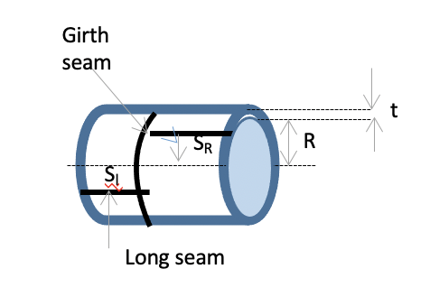

**Figure 9.1.3** Long Seam and Girth Seam in a Cylindrical Shell

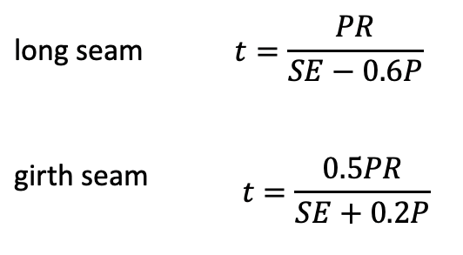

(Equation 9.1.8)

(Equation 9.1.9)

The material used for the construction of the flash tanks is A515 Grade 55 Carbon Steel, which has a maximum allowable strain of S = 13,600 psi, and a welded joint efficiency of E = 0.85 was assumed. In both cases, the long seam required the largest thickness and was used for design. The next highest nominal size of steel was used for safety assurances. The weight of the tanks was calculated using a relation of the tank to a cylindrical shell. According to Perry’s Handbook, the density of A515 Grade 55 Carbon Steel is 487.3 lb/ft3.

(Equation 9.1.10)

A summary of the dimensions of both flash tanks is found below in Table 9.1.3.

**Table 9.1.3** Flash Tank Dimensions

|  |  |  |
| --- | --- | --- |
| **Parameter** | **V201** | **V202** |
| **Diameter (ft)** | **4.0** | **3.5** |
| **Height (ft)** | **16.0** | **14.0** |
| **Wall thickness (in)** | **0.875** | **0.75** |
| **Weight** | **8037.0** | **5275.0** |

Cost analysis was performed for both flash tanks using a correlation presented by Seider et. al. (2016).

$C_{P,2013}=F_{M}C_{V}+C_{PL}$ (Equation 9.1.11)

$C_{V}=exp⁡[7.1390+0.18255\left(\ln{W_{tank}}\right)+0.02297{\left(\ln{W_{tank}}\right)}^{2}]$ (Equation 9.1.12)

$C_{PL}=410D^{0.7396}L^{0.70684}$ (Equation 9.1.13)

This correlation relates the weight of the tank to the purchased cost (CP) of the equipment. A material cost factor is reflected in the equations as FM, but was found to be 1.0 for carbon steel, having no effect on the cost in this particular correlation. This relation was designed to be accurate in 2013, with a CEPCI of 567.3, therefore the calculated values were adjusted using the CEPCI in 2020 of 596.2.

$C_{P,2020}=C_{P,2013}\left[\frac{{CEPCI}_{2020}}{{CEPCI}_{2013}}\right]$ (Equation 9.1.14)

Installation cost for a carbon steel flash tank was presented by Couper (2012) to be approximately increased by a factor of 2.8.

$Installation Cost=2.8×C_{P,2020}$ (Equation 9.1.15)

Compiled costs of both flash tanks are included in Table 9.1.4, as well as within the equipment data sheets in the Appendices.

**Table 9.1.4** Purchased and Installed Costs of Flash Tanks

|  |  |  |
| --- | --- | --- |
|  | **V201** | **V202** |
| **Purchased Cost ($USD 2020)** | **$52,325.00** | **$41,250.00** |
| **Installed Cost ($USD 2020)** | **$146,510.00** | **$115,500.00** |
| **Total Cost ($USD 2020)** | **$198,835.00** | **$156,750.00** |

*9.2 Reactors R101 & R102 Design and Cost Calculations*

For this process, two packed bed reactors in parallel utilizing H-ZSM-5 catalyst were designed. In order to accurately design the reactors, a rate equation with relevant kinetic parameters for the catalyzed ethanol dehydration reaction was required. Becerra et al. (2018) were able to develop a Langmuir-Hinshelwood kinetic expression for the reaction in the range of 200-300 °C. They were also able to develop kinetic parameters for their expression by non-linear regression with 95% confidence. Another key factor in the design of the catalytic reactors are the catalyst properties. Listed below are the relevant property parameters for the selected catalyst:

**Table 9.2.1** Relevant property parameters for the selected catalyst

|  |  |
| --- | --- |
| **Catalyst** | Molecular Sieve Zeolite H-ZSM-5 5A |
| **ρbulk (ton/cuft)** | 0.0218 |
| **DAve (mm)** | 2.0 |
| **Si/Al ratio** | 30 |
| **Price ($/ton)** | 1450.00 |

For the rate expression developed by Becerra et al. (2018), the partial pressures for each component involved in the expression (PA for ethanol, PE for ethylene, PW for water) were set to be a function of the conversion of ethanol. Note that for PW, an expression for the partial pressure of water as a function of ethanol conversion was not developed due to the k-2 parameter having a value of zero for all reaction temperatures. These equations are shown below:

(Equation 9.2.1)

$${-r}_{A}= \frac{k_{1}P_{A}-k_{-2}P_{E}P_{W}}{k_{2}+P_{A}K+P_{E}} [\frac{mol}{s g_{cat}}]$$

(Equation 9.2.2)

$$P_{A}= P_{A,o}\frac{1-X}{1+εX}$$

(Equation 9.2.3)

$$P_{E}= P_{A,o}\frac{X}{1+εX}$$

For the rate expression, the following parameters were developed:

**Table 9.2.2** Parameters developed for rate expression

|  |  |  |  |  |
| --- | --- | --- | --- | --- |
| **T(C)** | **k1** | **k2** | **K** | **k-2** |
| 200 | 9.71E-07 | 1.00E-08 | 5.68 | 0 |
| 220 | 1.10E-05 | 1.00E-08 | 7.22 | 0 |
| 240 | 1.80E-05 | 1.00E-08 | 5.25 | 0 |
| 260 | 2.30E-05 | 1.00E-08 | 4.6 | 0 |
| 280 | 2.40E-05 | 1.50E-02 | 3.35 | 0 |
| 300 | 2.40E-05 | 1.50E-02 | 3.35 | 0 |

The process conditions specify a reactor operating temperature of 300 °C. Using the developed rate equation and parameters, a plot of the inverse reaction rate versus ethanol conversion was developed.

**Figure 9.2.1** Inverse reaction rate versus ethanol conversion

In order to calculate the required volume of catalyst to achieve 99% conversion of ethanol, the following equation was used to develop a Levenspiel plot:

$V_{catalyst}=\frac{F_{A,o}\int{\frac{dx}{r_{A}}}}{ρ_{bulk}}$ (Equation 9.2.4)

**Figure 9.2.2** Levenspiel plot of Ethanol Conversion

From the plot above, it was determined that at X = 0.99, the total volume of catalyst required would be 7278.2 ft3. In order to prevent oversizing of equipment, two catalytic reactors are run parallel to each other, each taking on one half of the process stream. The reactors have an assumed void fraction of ε = 0.45, resulting in a reactor volume of 6616.5 ft3 holding 3639.1 ft3 of H-ZSM-5 catalyst. The following calculation was performed to determine the cost of catalyst per reactor:

$$C_{catalyst}=V_{cat}ρ_{bulk}P_{cat/ton}=3639.1 {ft}^{3}×0.0218\frac{ton}{{ft}^{3}}×1450\frac{\$}{ton}=\$115,294$$

Using the volume of the reactors, the radius and height were found. In order to find the dimensions of the reactor that would minimize surface area (therefore minimizing cost of MOC), the following optimization was performed:

$V_{Reactor}=πr^{2}h →h_{min}=\frac{V_{Reactor}}{πr^{2}}$ (Equation 9.2.5)

${SA}_{Reactor}=2πr^{2}+2πrh=2πr^{2}+2\frac{V_{Reactor}}{r}$ (Equation 9.2.6)

$\frac{d}{dr}\left[{SA}_{Reactor}\right]=4πr-2\frac{V_{Reactor}}{r^{2}}→r_{min}=\sqrt[3]{\frac{V_{Reactor}}{2π}}$ (Equation 9.2.7)

Using the volume of a single reactor, rmin was calculated to be 21.8 ft and hmin was calculated to be 4.4 ft.

Due to the high-pressure conditions of the process, it was necessary to calculate the pressure drop within each column. While the reaction itself is not highly dependent on the pressure of the vessel, a large pressure drop would result in increased equipment and utility costs around the first compressor in the separation train. The pressure drop was then calculated for each reactor using the following equations and parameters:

$\frac{P}{P_{o}}={\left(1-\frac{2β_{o}L}{P_{o}}\right)}^{1/2}$ (Equation 9.2.8)

$-β_{o}=-\frac{G}{ρ_{o}g_{c}D_{p}} x \frac{1-ε}{ε^{3}} x \left[\frac{150(1-ε)μ}{D_{p}}+1.75G\right]$ (Equation 9.2.9)

**Table 9.2.3** Ergun Eqn Parameters and Units

|  |  |  |
| --- | --- | --- |
| **Ergun Eqn Parameters** | | **Units** |
| ε, void fraction | 0.45 |  |
| gc, gravity | 4.170E+08 | lbmft/hr^2lbf |
| Dp, particle diameter | 6.562E-03 | Ft |
| μ, gas viscosity | 0.04495 | lbm/fthr |
| L, height | 59.6 | Ft |
| u, superficial velocity | 73.890 | ft/hr |
| ρ, gas density | 2.943 | lbm/cuft |
| G = ρu, superficial mass flux | 217.458 | lbm/sqfthr |

The corresponding pressure drop for the calculated dimensions of each reactor was determined to be 0.821, or an outlet pressure of 517 psia.

Assuming that the reactors are both cylindrical with flat heads, the following equation was used to determine the thickness of each reactor using annealed plates of MONEL-400 as the material of construction. For annealed plates of MONEL-400, the yield strength is 77,500 psi at room temperature and has a density of 0.318 lbm/in3. E, the weld efficiency, was assumed to be 0.90, and CA, the corrosion allowance, was assumed to be a quarter of an inch.:

$t=\frac{PR}{SE-0.6P}+CA=\frac{615 psig×261.6 in}{77500 psi×0.90+0.60×615 psig}+0.25 in=2.54 in$ (Equation 9.2.10)

The weight of each reactor unit was able to be calculated using the following equation: $W_{Reactor}=ρt\left[2π{r_{min}}^{2}+2πr_{min}h_{min}\right]=0.318\frac{{lb}_{m}}{{in}^{3}}×2.54 in ×\left[2π{(261.6 in)}^{2}2π(261.6 in)(53.2 in)\right]$

$$=422,635.6 {lb}_{m}$$

(Equation 9.2.11)

Using the cost factor for MONEL-400, FM = 3.6, the uninstalled cost of each reactor was then determined to be $159,659.12 by the following equations:

$C_{Reactor}=C_{b}F_{M}+C_{a}$ (Equation 9.2.12)

$C_{a}=2291{({2r}_{min})}^{0.2029}$ (Equation 9.2.13)

$$C_{b}=1.672exp\left[8.571-0.223\left(lnW_{Reactor}\right)+0.04333{\left(lnW_{Reactor}\right)}^{2}\right]$$

(Equation 9.2.14)

To determine the installed cost, the uninstalled cost of the reactor was multiplied by a factor of 2.8. The installed cost was determined to be $447,045.54. Listed below is a summary of both identical reactors.

**Table 9.2.4** Summary of both identical reactors

|  |  |  |
| --- | --- | --- |
| **R101/R102 Summary** | | **Units** |
| Diameter | 11.9 | ft |
| Height | 59.6 | ft |
| Pressure Drop | 0.821 |  |
| Reactor Weight | 422635.5742 | Lbm |
| Catalyst Weight | 159053.8541 | Lbm |
| Reactor Uninstalled Price | 159,659.12 | $ |
| Reactor Installed Price | 447,045.54 | $ |
| Catalyst Price | 115,294.28 | $ |
| Total Cost | 562,339.82 | $ |

*9.3 Fired Heater Design*

Before entering both reactors, the process stream needs to be heated to 572 °F. To achieve this large temperature increase, a single heated furnace was implemented into the process. From an Aspen Plus simulation, the heat duty to the stream was reported to be 1.262E+08 Btu/hr.

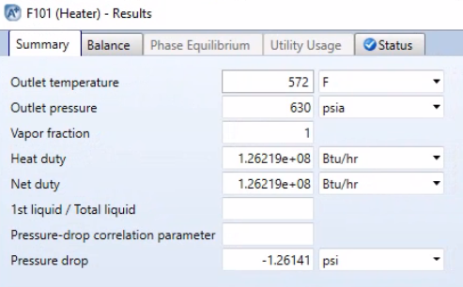

**Figure 9.3.1** Aspen Plus simulation for Heat Duty

Assuming that 25% of the heat duty to the stream is lost, the heat duty was multiplied by 1.25 for a total heat duty of 1.578E+08 Btu/hr. From Couper’s Chemical Process Equipment Selection and Design, the average radiant rate for atmospheric crude heaters is 10,000-14,000 Btu/sqft hr. For this process, the average radiant rate for atmospheric crude heaters is assumed to be 14,000 Btu/sqft hr. The heat release in the chamber is assumed to be 76,800 Btu/cuft hr, and the diameter of the tubing is assumed to be Dt = 2 in, with 25% of the tube sheet available for open flow. The following calculations were performed to determine the dimensions of the fired heater and the number of tubes within the heater:

$$V_{Fired Heater}=\frac{Total Heat Duty \frac{Btu}{hr}}{Heat Release in Chamber \frac{Btu}{cuft hr}}=\frac{1.578E+08}{76,800}=2054.3 {ft}^{3}$$

(Equation 9.3.1)

$${SA}_{tubing}=\frac{Heat Duty to Stream\frac{Btu}{hr}}{Heat Transfer Rate\frac{Btu}{sqft hr} }=\frac{1.262E+08 }{14,000}=9015.7 {ft}^{2}$$

(Equation 9.3.2)

$${SA}_{tubing}=π\left(D_{t}\right)HN_{t}→H_{Heater}N_{t}=\frac{{SA}_{tubing}}{π\left(D_{t}\right)}=\frac{9015.7 {ft}^{2}}{π\left(\frac{2}{12}\right) ft}=17219.2 ft$$

(Equation 9.3.3)

$$\frac{N_{t}\frac{π{\left(D_{t}\right)}^{2} ft}{4}}{\% Tube Sheet Available for Open Flow}=π\frac{{D_{Heater}}^{2}-{D_{Combustion Zone}}^{2}}{4}$$

(Equation 9.3.4)

$D_{Heater}=15.8 ft+{(1ft+1ft)}_{insulation}=17.8ft$ (Equation 9.3.5)

$H_{Heater}=15.8 ft$ (Equation 9.3.6)

$D_{Combustion Zone}$ (Equation 9.3.7)

$$N_{t}=1088 tubes$$

The installed cost of the fired heater was determined using the following equation, where k = 25.5 for Carbon Steel MOC, fd = 0, and fp = 0.10:

$C=1.218k\left(1+f_{d}+f_{p}\right){\left(Total Heat Duty \frac{Btu}{hr}\right)}^{0.86}$ (Equation 9.3.8)

$=1.218\left(25.5\right)\left(1+0+0.1\right){\left(1.578E+08\right)}^{0.86}$ (Equation 9.3.9)

$$= \$383,610,762.30$$

**Table 9.3.2** Fired heater Summary

|  |  |  |
| --- | --- | --- |
| **F101 Summary** |  | **Units** |
| Heat Duty to Stream | 1.262E+08 | Btu/hr |
| Actual Heat Duty | 1.578E+08 | Btu/hr |
| Heat Transfer Rate | 14000 | Btu/sqfthr |
| Heat Release in Chamber | 76800 | Btu/cufthr |
| Volume of Heater | 2054.3 | cuft |
| Total Surface Area of Tubing | 9015.7 | sqft |
| D uninsulated | 15.8 | ft |
| D with insulation | 17.8 | ft |
| H | 15.8 | ft |
| Dcz | 12.9 | ft |
| Nt | 1088 | tubes |
| Cost | 383,610,762.30 | $ |

*9.4 Compressor Design*

The product stream (S107) enters C201 at 572 ºF and 516.41 psia. Compressors are used to increase the pressure of the fluid stream for later use. The polytropic compressor design was used to calculate the parameters and dimensions for these compressors due to being the most realistic predictive values. [47] With an inlet volumetric flow rate of 3058.27 ft3/min, this corresponds to a polytropic efficiency of approximately 0.72, this was determined using Figure 7.1 below.



**Figure 9.4.1** Polytropic Efficiency Correlative Chart [52]

After determining the polytropic efficiency, the volumetric flow rate was used to determine the head coefficient (µ), impeller diameter (in, D), and the number of stages that the compressor would have determined by using Figure 7.6. These values correlated with the compressor having two stages, with a head coefficient value of 0.495, and an impeller diameter of 18”.



**Figure 9.4.2** Frame size, Impeller Diameter, and Head Coefficient Chart [52]

The use of a compressor also causes a slight temperature increase in the product stream. The temperature and pressure observed at the exit stream (S201) was 645 ºF and 652.7 PSIA. The outlet temperature can then be calculated using equation 3.11, where Tout is the estimated outlet temperature, Tin is the inlet temperature of the compressor, rc is the pressure ratio of the inlet and outlet streams, and Y is the adjusted polytropic ratio considering the polytropic efficiency $ƞ.$

Tout (ºF) = Tin*(rc)Y  (Equation 9.3.1)

$Y=\frac{k-1}{k}*(\frac{1}{ƞ}$) = 0.292 (Equation 9.3.2)

Rc = 652.67/516.41 = 1.264 (Equation 9.3.3)

Tout (ºF)= (1031.67 ºR) (1.264)0.292 = 645 (Equation 9.3.4)

The compressibility of the inlet and outlet streams were then calculated using the molar volume values. These molar volumes were given as 0.045 ft3/mol and 0.037 ft3/mol, respectively:

$Z=\frac{PVm}{RT}$ (Equation 9.3.5)

$$Z(in)=\frac{\left(516.41\right)\left(0.045\right)(453.594)}{\left(10.73\right)\left(1031.67\right)}= 0.945$$

$$Z(out)=\frac{\left(652.67\right)\left(0.037\right)(453.594)}{\left(10.73\right)\left(1088.2\right)}= 0.930$$

Next, the acoustic velocity (Ua) was determined using the heat capacity ratio (k), determined to be 1.25 for the ethylene stream along with the gas constant, inlet temperature and compressibility. The acoustic velocity was calculated to be 1471.05 ft/s.

$Ua \left(\frac{ft}{s}\right)=sqrt\left(k*g*\left(\frac{R}{Mw}\right)*Tin*Zin\right)$ (Equation 9.3.6)

$Ua(\frac{ft}{s})=sqrt(\left(1.264\right)*\left(32.2\right)*\left(\frac{1545}{22.825}\right)*\left(1031.67\right)*0.945))=1643.05$

The amount of power required for the compressor is determined based on the adjusted volumetric flowrate. The inlet volumetric flowrate given was 3058.27 ft3/min, when adjusted is calculated to 163.28 ft3/min as shown below. The volumetric flow rate was adjusted to account of the molar volumes of the streams.

$Qs (\frac{ft^{3}}{min})=Qss*\left(\frac{Patm}{Pin}\right)*\left(\frac{Tin}{Tatm}\right)*(\frac{Zin}{1})$ (Equation 9.3.7)

$Qs (\frac{ft^{3}}{min})=\left(3058.27\right)*\left(\frac{14.7}{516.41}\right)*\left(\frac{1031.67}{520}\right)*\left(0.945\right)=136.049$

From that, the specific volume of the stream was calculated to determine the mass flow rate. The specific value was found to be 0.888 ft3/lb. Then the polytropic head was calculated to be 15,867.79 ft*lbf/lb:

$Vs=\frac{Zin*Tin*g}{\left(Pin*Mw\right)}$ (Equation 9.3.8)

ft3/lb

(Equation 9.3.9)

$W=\frac{136.049}{0.888}= 153.253$ lb/min

$H=\frac{\left(Zin+Zout\right)}{2}\left(\frac{1545}{Mw}\right)*T(in)(rc^y-1)/Y$ (Equation 9.3.10)

$$H(ft*\frac{lbf}{lb})=\frac{0.945+0.930}{2}*\left(\frac{1545}{22.825}\right)*\left(1031.67\right)*\frac{{1.264}^{0.292}-1}{0.292}=15867.793$$

Before calculating the horsepower needed from the compressor, the speed of the impeller and the RPM were needed to be calculated in order to determine the overall horsepower lost to bearing and seal lost, which is based on the RPMs of the compressor calculated and the frame size. These values are then added to the overall horsepower needed for the compressor:

$U \left(\frac{ft}{s}\right)=sqrt(H*g/(Ns*µ)$ (Equation 9.3.11)

$U(\frac{ft}{s})=sqrt(\frac{\left(15867.79\right)\left(32.2\right)}{2*0.495})$ = 718.404

$N\left(rpm\right)=229*\frac{U}{Impellar Diameter}$ (Equation 9.3.12)

N (rpm) = 229 *(718.404)/18 = 9140

The calculation for the initial horsepower that the compressor needed was then done. The equation below utilizes the polytropic head, specific volume and polytropic efficiency:

$HP=H*\frac{W}{33000* ƞ}$ (Equation 9.3.13)

$HP=(15867.79)*\frac{153.253}{33000*0.728}$ = 101.23 HP

The horsepower lost to bearings and seal pressures was calculated using the charts in Figure 7.6. The final horsepower calculation is shown below.



**Figure 9.4.3** HP Lost Due to Bearing and Seal Loss [52]

HPLost = 84hp

HPneeded = 84hp + 101.23hp = 185.23hp

For the cost of a two-stage compressor, the following equation was used to calculate the cost, which came out to $201,186.03. [52] The utility cost was calculated below by using a fully loaded compressor at $0.09/kWh that is 80% efficient. [19]. The installation cost was calculated using the compressor cost multiplied by a factor of 2.2 [36]:

$Compressor Cost (\$USD)=7900{\left(HP\right)}^{0.62}$ (Equation 9.3.14)

$Installation Cost (\$USD)=2.2*Compressor Cost$ (Equation 9.3.15)

$$Cost= 7900*{\left(185.23\right)}^{0.62}=\$201,186.03$$

$Utility Cost (UC)= HP*(0.746)*(\$/kWh)*(\% loaded)/Efficiency$ (Equation 9.3.16)

$UC=$ 185.23hp * (0.746) *(0.09)*(100%)/0.8 = $15.54/hour



**Figure 9.4.4** Design Data for C201

*9.5.1 Heat Exchanger Design HX101*

The products stream leaves the first compressor (C-201) at 628.509 F and 652.67 psia and the stream needed to drop in temperature and pressure to 212 F and 642.662 psia in order to enter the first flash tank (FL 101). To achieve this, energy transfer between ground water and the products streams was achieved using a shell and tube heat exchanger. For both heat exchangers (HX101 and HX102), Aspen’s heat exchanger design and rating application was used to simulate and size the respective shell and tube heat exchangers. Inlet and outlet flow rates, temperatures, vapor mass fraction, absolute pressure, and heat exchanged were pulled from our process flow diagram for streams S201 and S202 and inserted into their respective fields as seen in Figure 9.5.1.

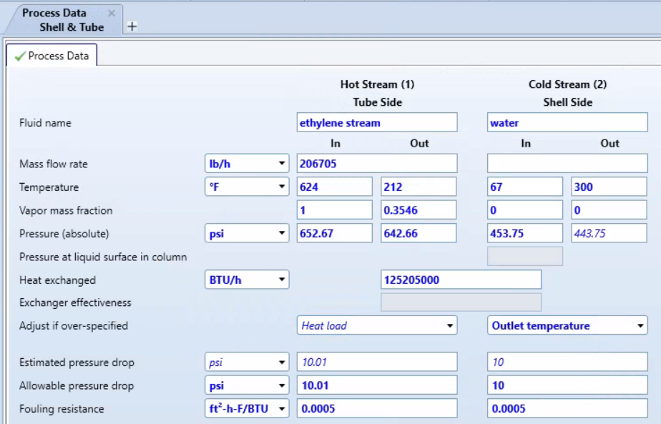

**Figure 9.5.1** Shell and Tube Process Data

For the shell side coolant, ground water was used to cool the tube side product stream. The inlet of 67 °F was used as that is the average temperature of ground water found in Texas which is where the final plant will be located. An estimate of the outlet temperature of the shell side was used and the simulation calculated the required mass flow rate of water needed to reach the desired heat load. After the process data was inserted, the composition (mass fraction) of the fluids in both the shell and tube sides were specified in Figures 9.5.2 and 9.5.3.

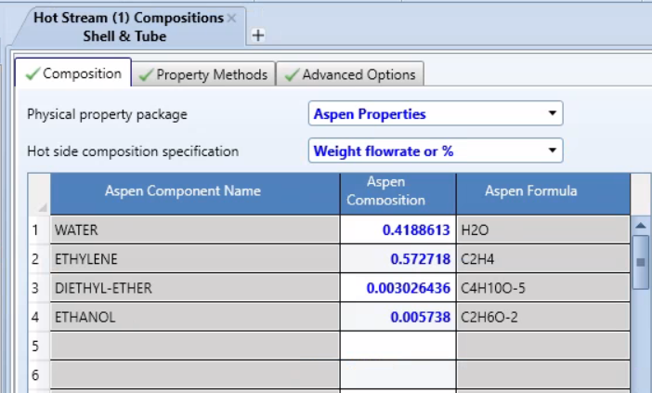

**Figure 9.5.2** Hot Stream (Tube Side) Mass Fractions

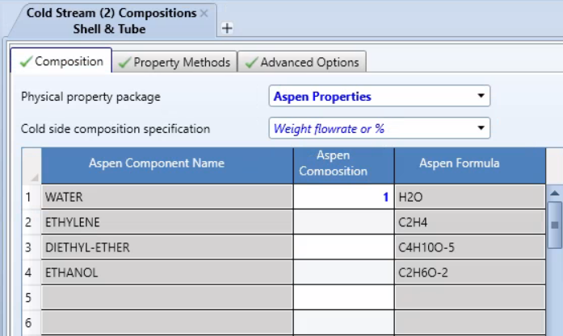

**Figure 9.5.3** Cold Stream (Shell Side) Mass Fractions

The default material of carbon steel was used as the material of construction for the heat exchangers as it can undergo a variety of pressures and temperatures with relatively low corrosion. Once all of this information was inserted into the simulation, the simulation was ran and a series of heat exchanger designs were reported and the cheapest exchanger capable of safely carrying out the desired heat exchange was selected. Figure 9.5.4 shows the output of these designs. The bottom highlighted design is the design used to fill out the equipment data 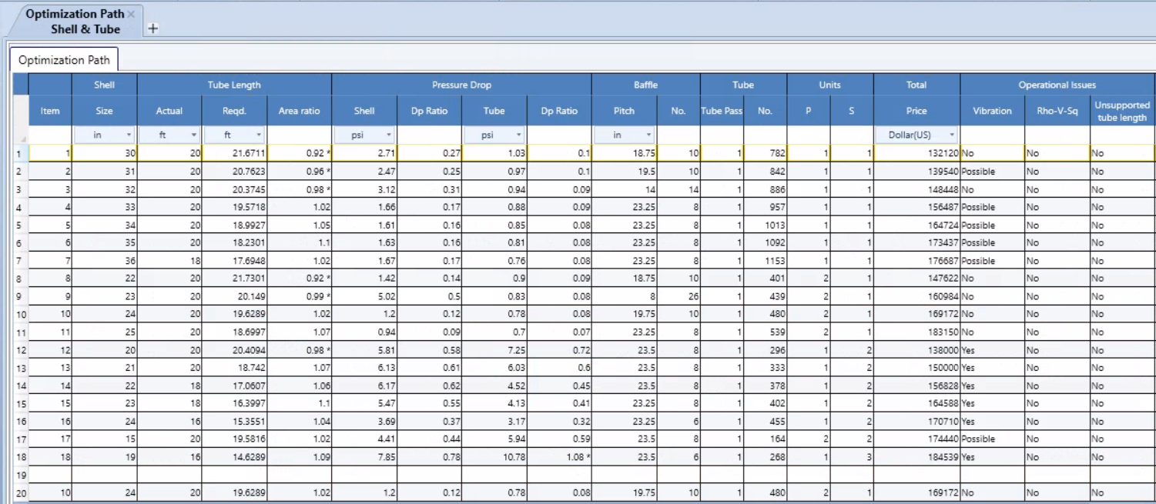sheet.

**Figure 9.5.4** Optimal Design Comparison

In the results tab, a TEMA Sheet is produced containing various dimensions and design details for the heat exchanger that were used in the equipment data sheets. The TEMA sheet for exchanger HX101 is shown in Figures 9.5.5 and the cost analysis is shown in Figure 9.5.6.

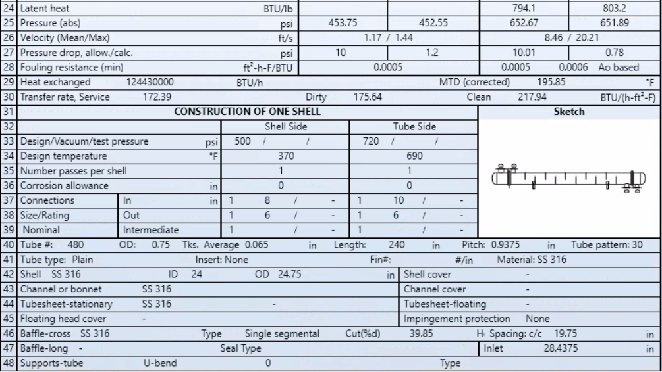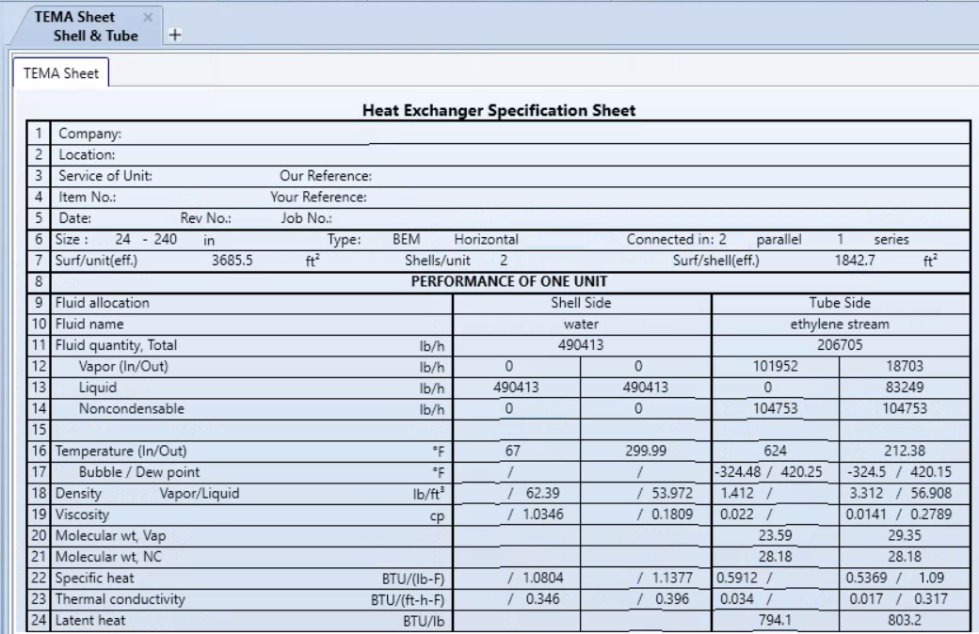

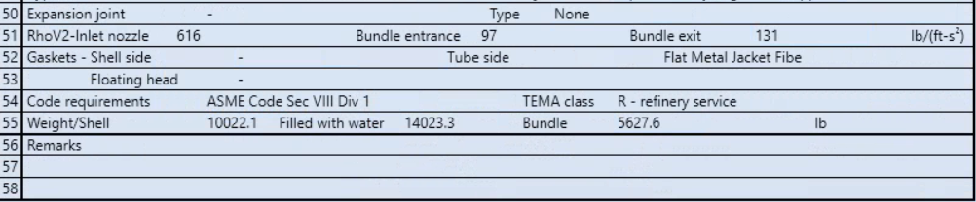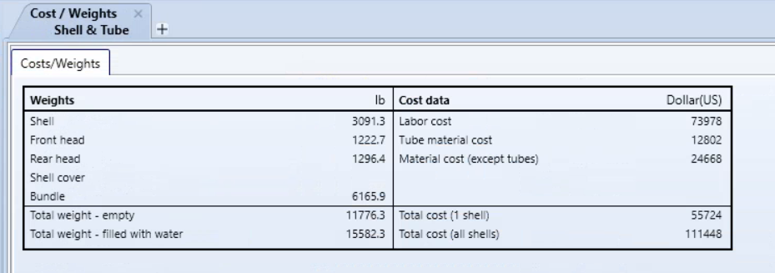

**Figure 9.5.5**  TEMA Sheet for Exchanger HX101

**Figure 9.5.6** Table of Weights and Costs of Equipment

*9.5.2 Heat Exchanger Design H102*

Aspen Heat Exchanger Design and Rating software was also used to design the second heat exchanger (HX102). The only difference between the way each was designed is in the coolant used. Exchanger HX102 needed to use Freon as the coolant as the temperature of the product stream had to drop to 32 F. In order do this successfully, a coolant with a lower freezing point than water had to be used because the water in the shell side would freeze during heat transfer in this exchanger. Aside from the coolant, the steps in the simulation were the same and the read outs are reported in the Figures below.

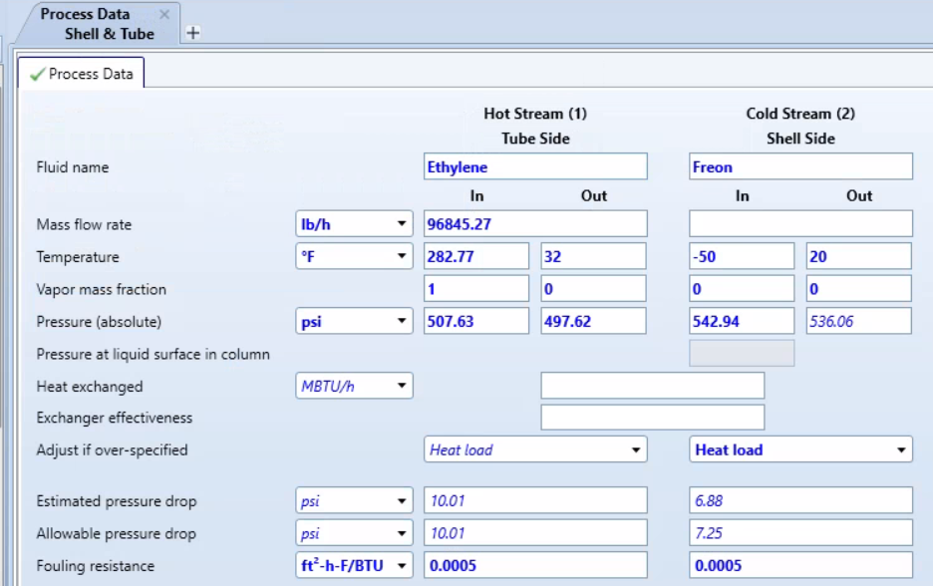

**Figure 9.5.7** Shell and Tube Process Data

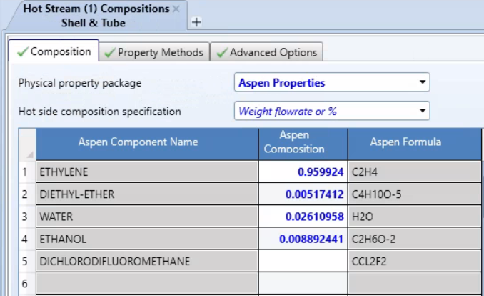

**Figure 9.5.8** Hot Stream (Tube Side) Mass Fractions

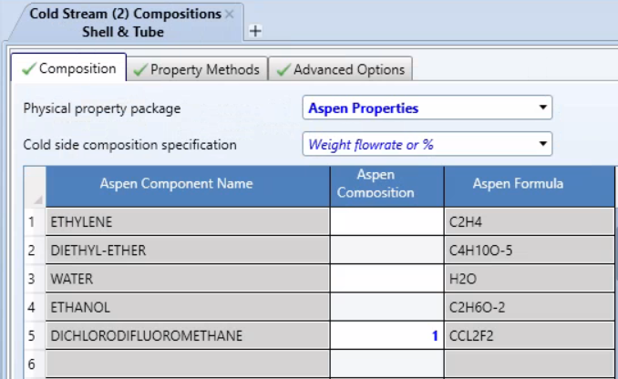

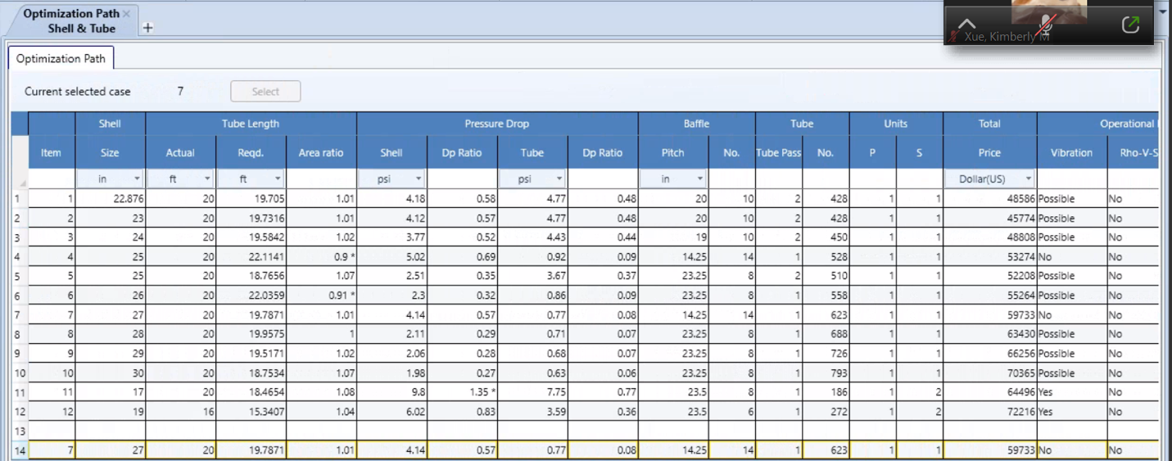**Figure 9.5.9** Cold Stream (Shell Side) Mass Fractions

**Figure 9.5.10**Optimal Design Comparison

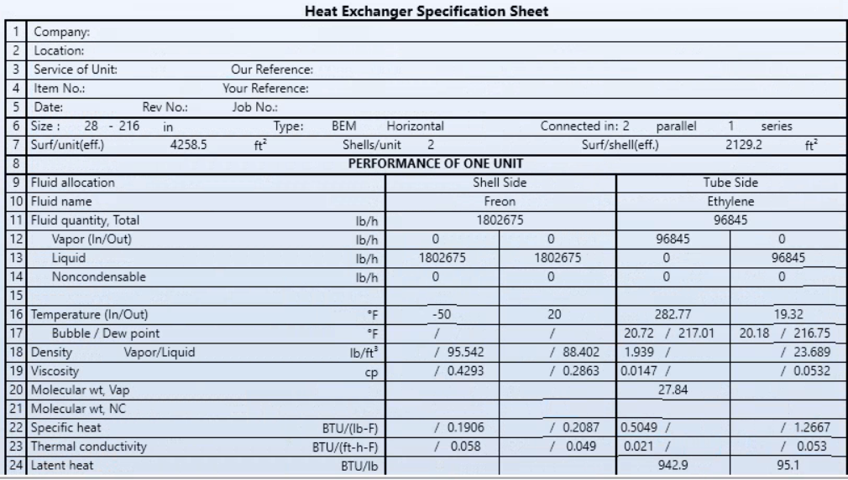

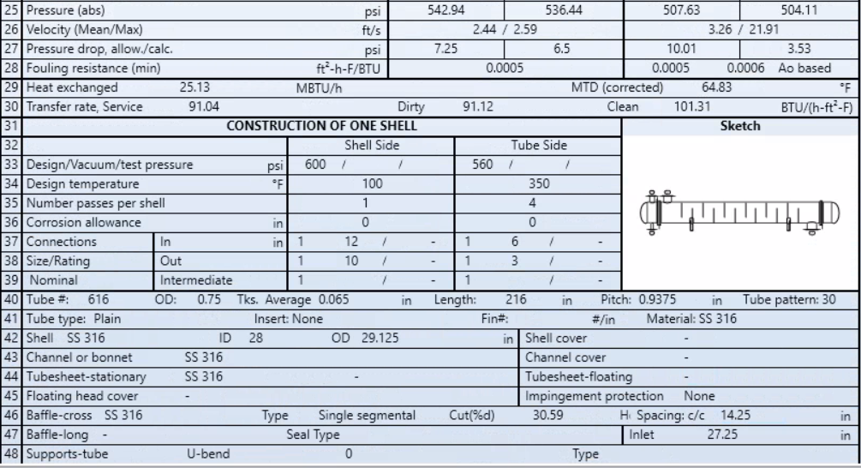

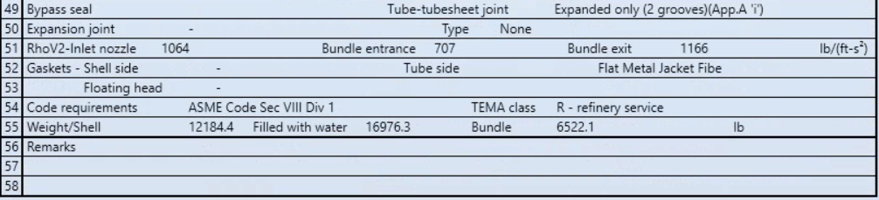

**Figure 9.5.11** TEMA Sheet for Exchanger HX102

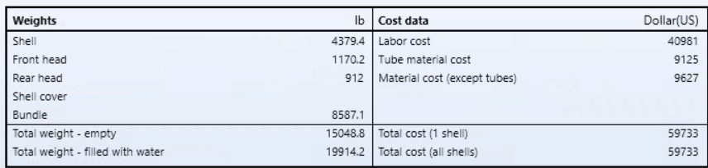**Figure 9.5.12** Table of Weights and Costs of Equipment

*9.6.1 Distillation Colum T201 Design & Cost Calculations*

To design the distillation column, the following parameters were obtained from the shortcut distillation block DSTWU using the Winn-Underwood-Gilliland method.

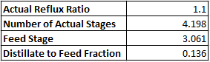

**Figure 9.6.1** DSTWU results

These parameters were then input to the RadFrac block to begin simulating a more realistic distillation column. The results from the shortcut method were a good starting point, however there was a lot of trial and error that went into the design of the column. The following screenshots from the Aspen Plus V10 simulation reflect the parameters that resulted in a working column.

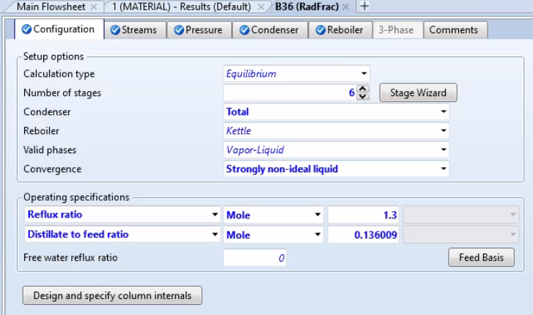

**Figure 9.6.2** Configuration for RadFrac distillation block

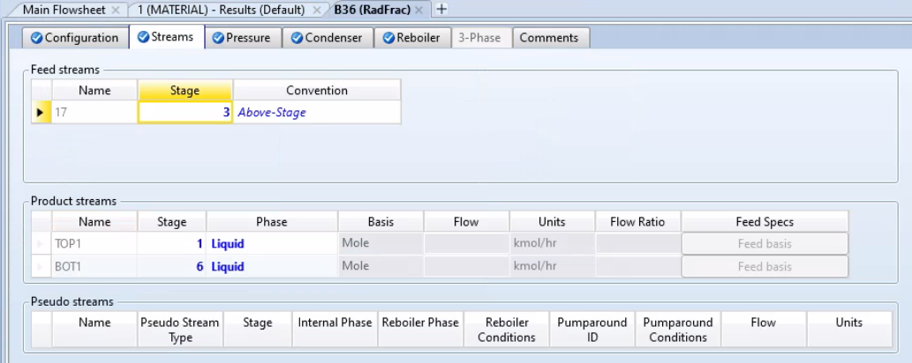

**Figure 9.6.3** Stream Parameters for RadFrac distillation block

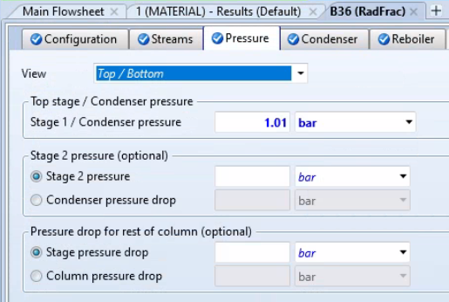

**Figure 9.6.4** Pressure Parameters for RadFrac distillation block

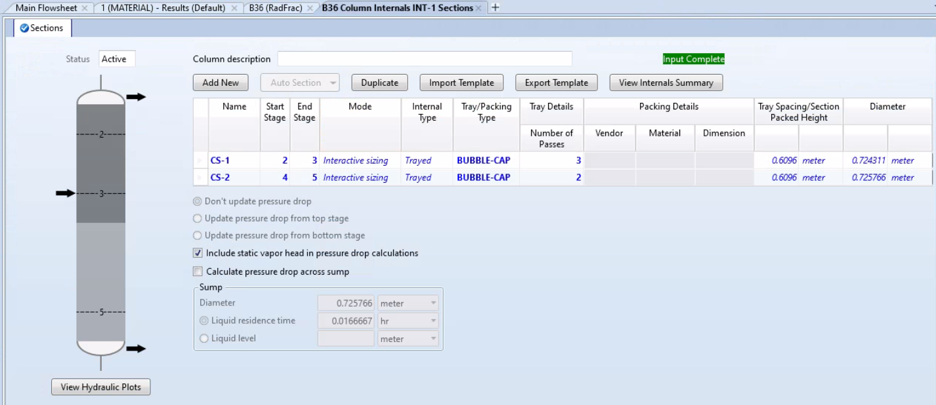

**Figure 9.6.5** Column Internals of RadFrac distillation block

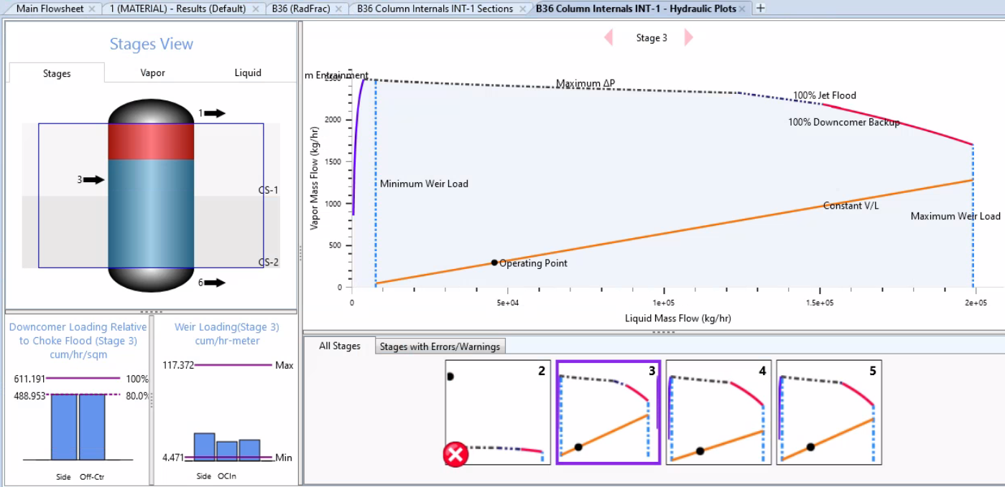

**Figure 9.6.6** Hydraulic Plots for RadFrac distillation block

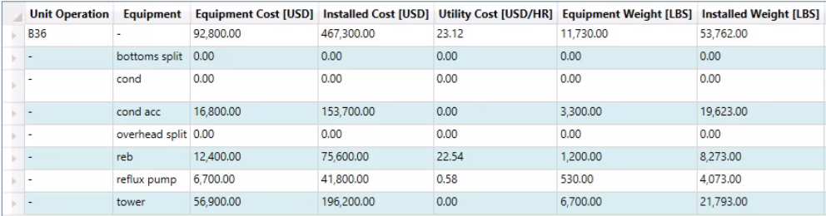

**Figure 9.6.7** Cost Summary for RadFrac distillation block

*9.6.2 Distillation Colum T202 Design & Cost Calculations*

To design the distillation column, the following parameters were obtained from the shortcut distillation block DSTWU using the Winn-Underwood-Gilliland method.

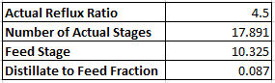

**Figure 9.6.8** DSTWU results

These parameters were then input to the RadFrac block to begin simulating a more realistic distillation column. The results from the shortcut method were a good starting point, however there was a lot of trial and error that went into the design of the column. The following screenshots from the Aspen Plus V10 simulation reflect the parameters that resulted in a working column.

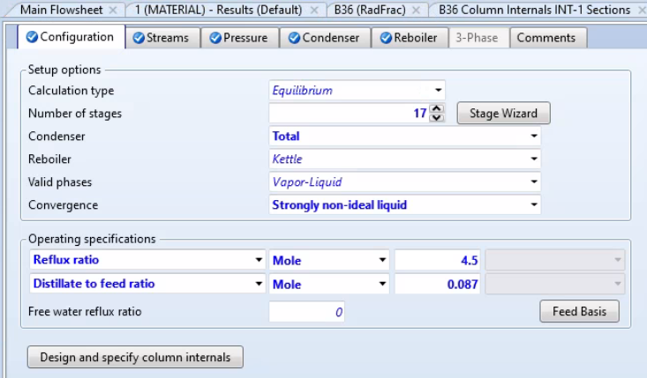

**Figure 9.6.9** Configuration for RadFrac distillation block

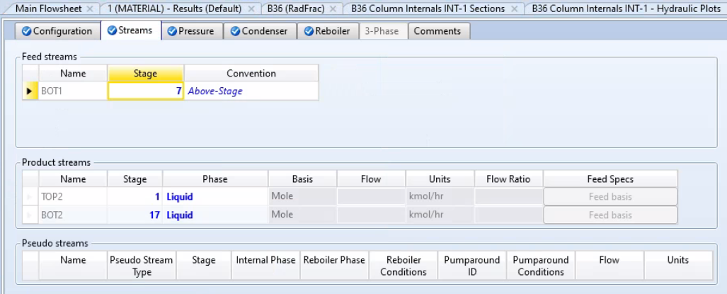

**Figure 9.6.10** Stream Parameters for RadFrac distillation block

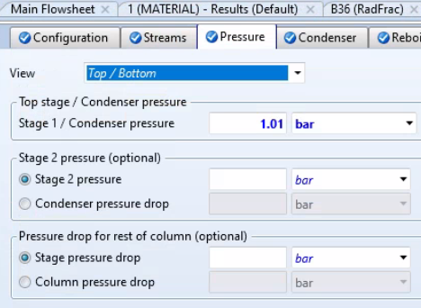

**Figure 9.6.11** Pressure Parameters for RadFrac distillation block

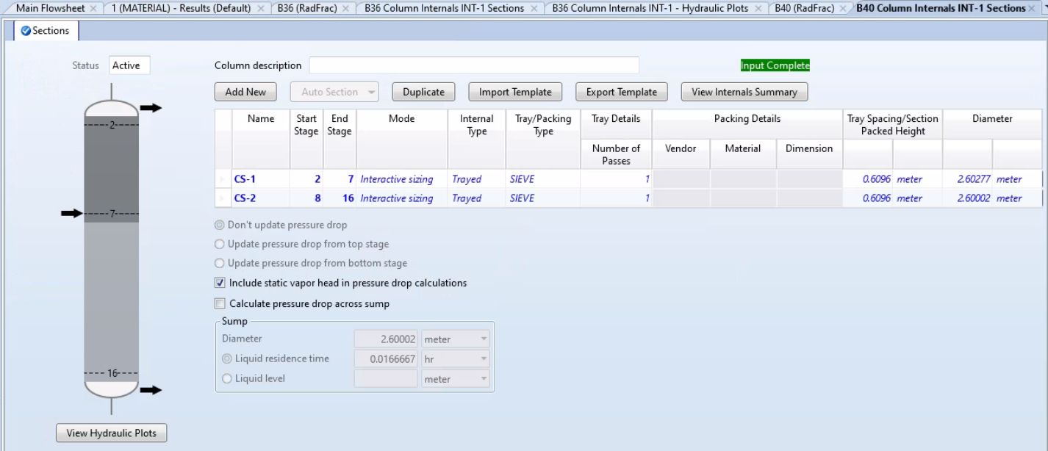

**Figure 9.6.12** Column Internals for RadFrac distillation block

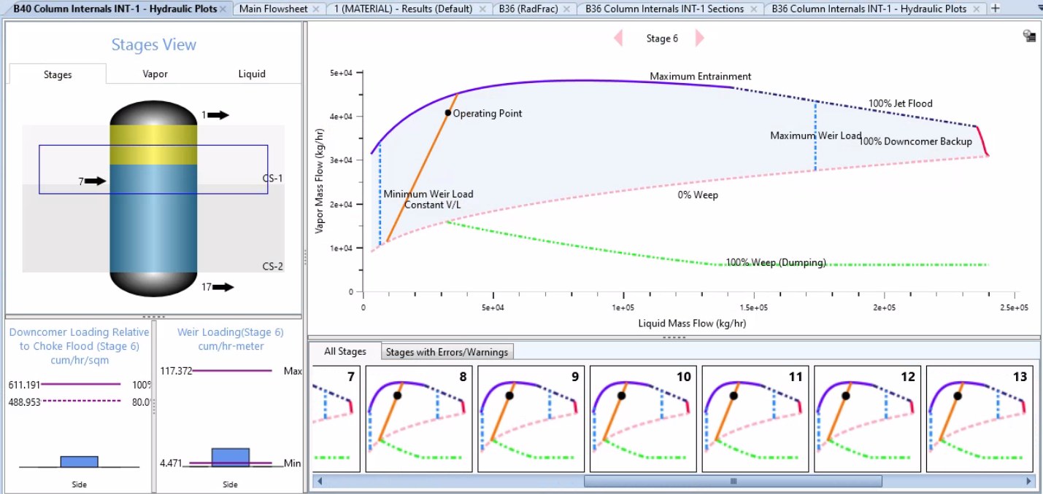

**Figure 9.6.13** Hydraulic Plots for RadFrac distillation block

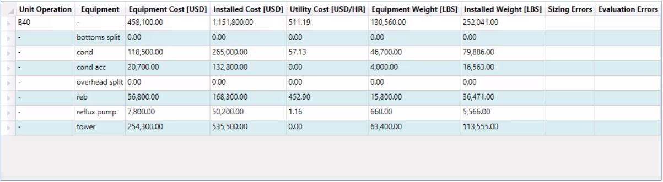

**Figure 9.6.14** Cost Summary for RadFrac distillation block

Listed in the table 9.6.1 is the summary of all equipment designed for this plant.

**Table 9.6.1** Equipment List Summary

1. **Relevant Safety Concerns and Design Issues**

Safety concerns are relevant to all plants as problems and disaster events can arise from issues in the plant layout, materials compatibility, lacking or poor contamination control, lacking physical facilities, poor inspection and maintenance, poor material handling, poor response to emergencies, and lacking or poor protective systems [25].

Plant layout concerns include separation and isolation as the feed storage of ethanol should be separated from the storage of produced ethylene. This is because, as shown in Table 1.1 and Table 1.3, both chemicals have a fire rating of 3 or above. This means if storage of one of these chemicals caught fire and an explosion would happen, they should be separated to avoid a secondary incident. Plant layout concerns also include drainage as could have a leak in vessels or piping [25]. This a concern in this plant as are dealing with liquid and gaseous materials. Should involve dykes to control if leaks would arise for liquid leaks. For gaseous leaks should take into consideration air flow around plant and how populated surrounding area is to plant for public safety [25].

Materials compatibility is important for the plant as certain construction materials may interfere with the chemicals. The incompatible materials cannot be used for process equipment, piping, or storage systems [25]. Contamination control is an important safety concern as contaminants could easily enter the system during transfer from one vessel to another, either during hookup or disconnect, or during a cleaning. This contamination could lead to undesired reaction that could be harmful or deadly.

Physical facilities include emergency eye wash or shower stations, fixed fire suppression equipment, and portable firefighting equipment [25]. These physical facilities are important to safety as the plant deals with flammable and potential toxic chemicals. Inspection and maintenance are vital to check for normal wear and corrosion. Inspection and maintenance are also important to check on safety valves and systems [25]. This should be done often but a major check would done during plant shutdowns, like when the catalyst must be replaced every 90 days.

Poor material handling comes into place for feed and production materials. If material handling for feed material is not properly checked on this can lead to unintended reactions or the plant not running at full efficiency [25]. Poor material handling of production materials can lead to a disaster as many of the production materials are flammable and could lead to safety problems for the area surrounding the plant if waste production materials are not properly disposed of.

Poor emergency response is an issue with a lot of facilities, which could lead to huge disasters if the emergency is not handled properly. In case an emergency were to happen, the best to handle one is to have a plan prepared for the type of emergency. There should be a different plan for different kinds of emergencies, for example, fires or explosions, at different levels of severity [25]. The plan should be simple, practical, and easily understood. These plans should be regularly updated, and drills should be conducted with all people in the building. Finally, protective systems include pressure relief systems, blow out preventors, cooling systems if overheating occurs, and an emergency shutdown [25]. These protective systems are important to consider for the plant as there are multiple streams with high pressure and high temperature. The emergency shutdown is also a very important safety measure if a runaway reaction occurs or in the case of a disaster event occurs the plant can immediately shutdown.

1. **Simulation and Optimization Results**

A sensitivity analysis was performed in Aspen Plus V10 on flash tank V201 and V202 to test the effects of temperature and pressure on the separation capabilities. In both flash tanks, it was observed that a higher operating pressure resulted in better separation of ethylene from water, ethanol, and diethyl ether. It was also observed in both flash tanks that lower operating temperatures resulted in better ethylene separation.

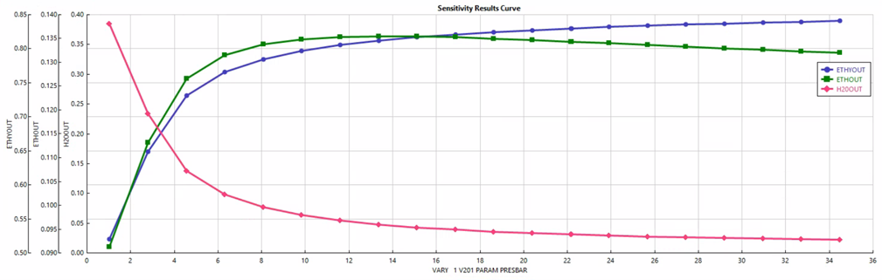

**Figure 11.1** Effect of Pressure on V201

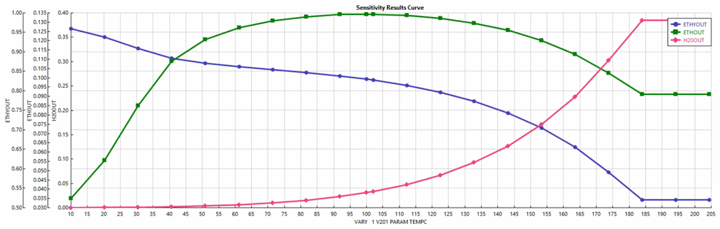

**Figure 11.2** Effect of Temperature on V201

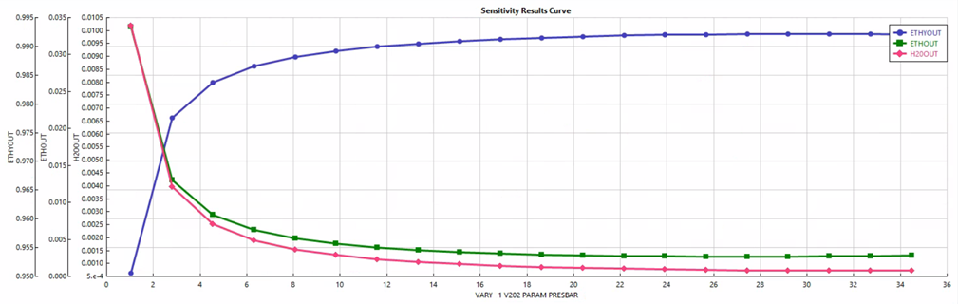

**Figure 11.3** Effect of Pressure on V202

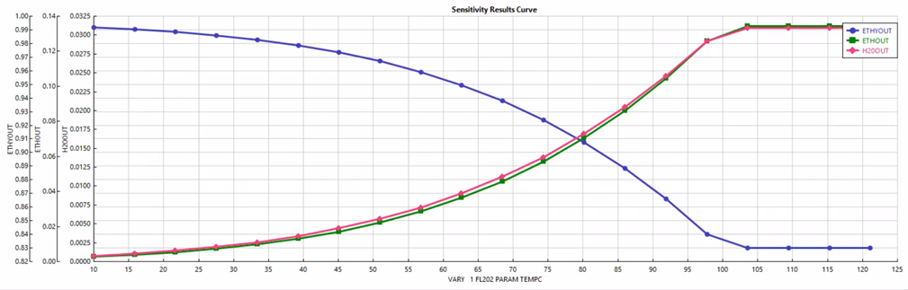

**Figure 11.4** Effect of Temperature on V202

1. **Process and Instrumentation Diagram**

For each piece of equipment in the plant design, process control is an important consideration. Process control is comprised of the several systems that measure parameters of inlet and outlet streams, the compositions of the streams, and prevent any deviation from the quality standards. In each plant, process control is put into place for every major piece of equipment. For this plant, a singular flash tank process control design was considered for implementation. The figure below shows the process and instrumentation diagram (PID) for one of these flash tanks.

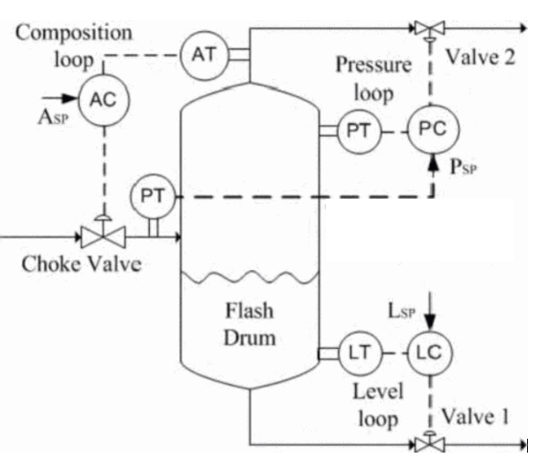

**Figure 12.1** PID Diagram for Flash Tank System [54]

The process control scheme in figure 12.1, was a proposed design for flash tank operation. Process control systems are implemented to utilize feedback control so that the equipment and overall plant to keep a stable operation. For each of the valves in this system, there is an implementation of different valves, transmitters, and controls that work together to keep the system stable. For figure 12.1, the choke valve has a pressure transmitter that works concurrently with the pressure control shown near valve two. Along with an additional pressure transmitter, this creates a pressure control loop, that monitors and corrects any deviation from operating conditions. If the pressure is too low, more feed would be pumped into the tank and pressurized through the choke valve, while if the pressure is too high, the opposite would happen. [54]

Similarly, there is a process control scheme for the composition of the streams as well as the level of the stream out of valve one. The composition process loop is implemented in place to monitor the composition of the streams in and out of the flash tank. Given that a flash tank’s goal is to separate a mixed vapor and liquid stream, keeping the composition of the streams in both outlet streams up to operating conditions is vital. If the composition deviates, the controls may have to increase the rate of boiloff in the tank to compensate.

The use of process control increases ability for the system to run more independently. Together, these process control schemes ensure the ability for production of consistent product quality and maximum efficiency of the plant. Although this is one example of process control implementation, other systems are not outlined for this plant design even though they are used.

1. **Site Selection**

Figure 13.1 depicts the layout of the plant. The site was estimated to be about 225 acres in size due to guidelines set by the Global Asset Protection Services (GAPS) in order to protect property and prevent any disasters from occurring. The distance between tanks and process equipment could change due to atmospheric conditions such as wind speeds, thermal radiation, or temperature. Taking all of this into consideration, GAPS suggested that 151 ft between storage tanks, and 351 ft between the tanks and process equipment to help prevent any major losses [44]. Texas laws also suggested that the facility must maintain 440 yds away from the surrounding area, which includes neighborhoods, schools, places of worship, and more [45]. As shown, every facility is 0.1 mi away from each other, which helps to lessen the impact of a potential disaster.

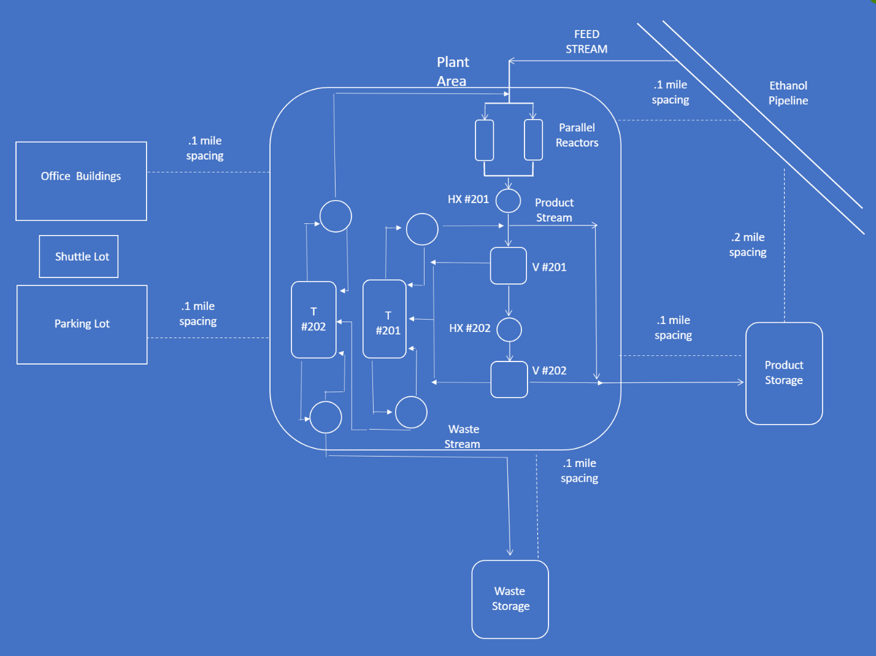**Figure 13.1** The layout of the plant and surrounding structures

The Texas site was selected to be in San Antonio, the second most populated city, on Applewhite Rd in Bexar County [46]. It is a large plot of land, boasting 226 acres. It is a commercial property, and it costs $1,938,000. The area is known for sand aggregate and mineral reserves, so it is very qualified to be used for industrial purposes. The space is very open, and it should provide enough space to be able to build an ethylene plant of this size.

The Panama site will be in Tonosi, Panama [53]. It is 230 hectares in size, which is about 568 acres. This will be more than enough space for the plant, especially considering the distances needed to keep the storage tanks and process equipment apart. The lot costs $1,725,000.

During the design of the ethylene plant, ethical and professional considerations were made keeping in mind the global, environmental, economic, and social impacts of both the plant and the final products. To begin, the global impacts at the site in San Antonio, Texas and Panama were considered. In North America, the US was the sole exporter of ethylene in 2019 with a value of around $225 million. Of the cities in the US that export ethylene, Houston, Texas was responsible for over half of these export sales making the choice of Texas as the final plant location appealing.[29] In contrast, Panama just started exporting ethylene and other liquified chemicals to Jamaica.[30] A new plant in Panama could help to increase the exports of ethylene in the area. Global end uses for ethylene is mostly in the product of polyethylene that has a variety of uses which makes it so versatile and in high demand. These uses include most plastics and packaging of consumer goods. In fact, packaging accounts for more than half of ethylene derivative consumption globally.[31] With this high demand globally comes the downside of global pollution.

Environmental impacts of the ethylene plant in Texas and Panama were considered in its design. In both Texas and Panama natural disasters pose a significant risk towards chemical plants with the possibility of accidents if not properly prepared for them. In Panama, there is a significant risk of earthquakes which can not only destroy building but also cut off utility and emergency services [32]. The plant would need to plan for a potential earthquake so that it could withstand the forces within an earthquake. In Texas, climate change has resulted in more extreme natural disasters, such as snowstorms and tornadoes, resulting in growing concerns over underprepared facilities [33]. The plant would need to be prepared for not only the current weather patterns, but potentially worsening weather in Texas in order to avoid spills.

Spills pose a significant environmental risk in both Texas and Panama. Ethanol poses a health risk to freshwater plants and animals as well as the bacteria present in the environment [9]. Ethylene released in a spill would be in a gas form which commonly degrades in the air into formaldehyde [33]. Ethylene exposure to plants results in stunted growth. Diethyl ether has a low toxicity to aquatic life and is not considered to bioaccumulate [12]. Thus, diethyl ether, which is a side product and would be present in smaller quantities, would not be considered much concern in the case of a spill.

The construction of this chemical plant carries multiple social impacts including increased gender equality and social anxieties developing from potential disasters. With the plant’s construction in Texas, there are multiple environmental hazards including hurricanes, tornados, and flooding. These hazards can give rise to concerns of a disaster such as the explosion in Soja City, Okayama Prefecture, Japan, which occurred following flooding caused by a tsunami [34]. This kind of fears can lead to social distrust or even lobbying against the continued existence of the plant if the safety is called into question. There is also a potential to affect gender equality especially in the setting of Panama, being part of the developing world, has a gender equality gap that has been decreasing as the availability of work [35]. This availability would be produced following the opening of a new plant as it takes in various employees and creates careers around the company such as transportation. Yet the social impacts are less prevalent in the other location, as Panama is less susceptible to hurricanes than Texas, and Texas as part of the developed world has a smaller gender disparity, that is still present in both locations. The issue of social fear is resolved by considering safety precautions that abide by local regulations, such as a quarter mile distancing between reactors products and raw materials. In both locations, safety is improved by employment providing the potential of increased healthcare availability, as neither location has universal healthcare. Access to healthcare helps to equalize social disparity for those previously unable to afford health insurance, improving their overall quality of life.

Both locations have reliable transportation via shipping thanks to being located close to major bodies of water. The plant in Panama would be the most prevalent example of access to water as the rater small land mass has easy access to the Atlantic and Pacific Oceans, as well as the trade hub of the Panama Canal enabling easy usage of shipping of the products and needed raw materials with minimal usage of plane or trucks for transportation. Texas, meanwhile, borders the Gulf of Mexico and Rio Grande but with a larger expanse of land away from the shore the use of trucks becomes more prevalent than in Panama. The effects from the plant’s construction in Texas as the metropolitan area of Houston already produces the majority of the ethylene in the United States. This is harshly contradicted by Panama which has a significant trade deficit with a lack of refined products to export [36]. This deficit displays a lack and need of factories such as an ethylene plant to provide, which would have a larger social impact. Given the lack of refined exports from Panama the is reason to believed that there would be a lack of trained technicians for a plant, but the opposite would be true in Texas where there is already a large amount of ethylene being produced. The potential workforce in Texas may be even better given the possibility of previous experience working with ethylene.

1. **Environmental Regulations**

In this process, the most hazardous component would be the side product, diethyl ether. Although, there is so little produced that it does not pose a major hazard to the environment, it is still hazardous, very volatile, and cannot be left alone. Regardless of the amount produced, hazardous waste must be dealt with.

In Texas, the Texas Commission on Environmental Quality (TCEQ) is the state level environmental agency. It is divided into different offices that deal with air, quality, water management and treatment, and enforcement.

The Clean Air Act (CAA) regulates air emissions. It authorizes the Environmental Protection Agency (EPA) to establish National Ambient Air Quality Standards (NAAQS) to regulate air quality and emissions [43]. Every state is to develop a state implementation plan (SIP) in order to uphold these regulations, and these are to be submitted to the EPA for approval. In San Antonio, any business that can potentially produce air pollution, according to the TCEQ, must register with the San Antonio Metropolitan Health District and pay an annual fee of $200 per facility [44]. According to Title 30, no one can use anything that can pretend to minimize or conceal the effects an emission might have [45]. If any violations occur, the attorney general or legal staff of the TCEQ could prosecute.

The Clean Water Act (CWA) regulates sources of potential sources of pollutants that can harm the water [46]. Under it, the EPA authorizes the National Pollutant Discharge Elimination System (NPDES) programs on state, tribal, and territorial levels. In Texas is one of the states with the authority to administer the NPDES programs. The NPDES was later replaced by the Texas Pollutant Discharge Elimination System (TPDES). In Texas, a permit is required to discharge wastewater into the waters into the state. In order to get an industrial wastewater permit, the establishment must fill out a technical report as the main body of the application [47]. Some of questions asked by the application include a description of all processes that generate wastewater, a materials list, and information regarding outfall. After being reviewed by the TCEQ, the public would be informed and have input on the proceedings. The facility would also have to pay an Annual Water Quality Fee.

Title 30 also refers to regulations regarding environmental quality. Chapter 335 deals with industrial solid waste and municipal solid waste. According to Rule §335.473, all facilities, regardless of quantity of hazardous waste produced, must develop a pollution prevention plan following the Waste Reduction Policy of 1991 [37]. §335.474 states that the plan is to be updated whenever changes are made, along with guidelines of what to include in the plans [37]. It is stated that Rule §335.43, it is illegal to store, process, or dispose of hazardous waste without a permit from the Texas Commission regarding Environmental Quality [37]. §335.63 states that the generator of the hazardous waste is not to store, process, dispose of, or transport said waste without permission from the EPA [37].

In Panama, the Ministry of Environment oversees public property in protected areas along with arranging plans for the conservation of the environment and natural resources [38]. It develops periodical programs in order to train personnel and other public or private entities regarding regulation. The Ministry of Environment is also the one to impose fines for those who violate these regulations, which are proportionate to the severity of the damage done [38]. In Section V, regarding solid and hazardous waste, the waste is separated into different categories: Differentiated collection, hospital waste, dangerous waste, or special handling of dangerous waste. New construction applications are zoned into three categories of increasing concern towards environmental impact in an Environmental Impact Study (EIS), which is administered by the Ministry of Environment. The ethylene plant would likely fall under Category 2: “applicable to projects that may cause significant environmental damage but where that damage can be eliminated or mitigated through well-known and easily applied means” [39]. An Environmental Management Plan (EMP) must be included in the EIS, and the plan needs to establish every detail of the activities, including prevention and mitigation, and possible impacts on the environment [39].

The Ministry of Environment could also require an environmental audit for certain projects in fields such as mining, production of hydrocarbons, forestry, agriculture, transportation, and tourism [39]. In this plant, an environmental audit that is independent of the company will be needed, as it is producing a hydrocarbon, which in this case, is ethylene. If the audit does not meet the standards, an Environmental Adaptation and Management Program (PAMA) would be developed by the company and submitted to the Ministry of Environment to ensure compliance with current environmental laws [39]. If the PAMA is violated, the company can face fines up to $10,000 USD, and it may be doubled for repeat offenses. Businesses can also have their activities suspended for varying amounts of time.

1. **Green Technologies**

Several steps can be taken to make the design of the plant more environmentally friendly. These include improving the catalyst and making heating systems more efficient.

To be more environmentally friendly, the system could use a different catalyst that requires less maintenance or produces fewer byproducts. As stated by J. Garcia, in order to become more environmentally friendly, companies need to reduce or eliminate waste production [40]. By choosing a catalyst that needs to be replaced less often, the waste produced by discarded catalyst would be reduced.

Several steps can be taken in order to make the heating systems more eco-friendly. Some options are possible with current technologies, whereas others rely on future research and improvements. In order to reduce the waste heat generated by the system, the heat exchangers downstream, H101 and H102, could be paired with the stream exiting pump P101 to heat it before it enters the fired heater. This would allow for fewer flue gases to be used within the fired heater as the temperature differential would decrease. While not widely available, heaters have been produced that implement biogas derived from agricultural waste, wastewater plants, and landfills as a fuel [41]. These heaters produce fewer emissions and eliminate waste buildup that would otherwise produce methane gas [42].

Future technological improvement in heaters could produce better sensors, heat generation, and heat containment [43]. The improvement of sensors would allow for more accurate heating through improved thermoregulation, thus limiting the amount of wasted flue gases. Improving heat generation systems would require optimizing thermal efficiency, either through better control of air-fuel ratios or improved efficiency of combustion. Optimization of insulation and seals could improve heat-containment and reduce heat losses.

1. **Economic Analysis**

Since all costs, design, and site selection are now considered, profitably can be determined. One thing to take into consideration when determining profitability is the total capital investment. The total capital investment (TCI) is calculated from the FCI, the plot of land, as well as the working capital (WC). Working capital is estimated between 15%-20% of the fixed capital investment. For this plant design the upper end, 20% was considered. Table 15.1 displays the monetary value of the TCI.

**Table 15.1** Summary table of total capital investment

|  |  |
| --- | --- |
| **Description** | **Value** |
| FCI | $197,693,563.95 |
| WC | $39,538,712.79 |
| Land | $1,938,000.00 |
| TCI | $239,170,276.74 |

When computing profitability it is important to note that the construction of the plant needs to be taken into account. The construction timeline for this plant design is two full years, with the bulk of the construction taking place in year one. Further analysis of the construction timeline will be provided in the latter. Year three is the first revenue generating year. Although the plant will not be at full capacity due to extended downtime and possible further construction, it is projected to run at 50% capacity. The second revenue generating year, year four will also not be at full capacity. The capacity in year four is estimated to be 80% and in year five the plant will reach full capacity. Table 15.2 supplies a summary with dollar values.

**Table 15.2** Revenue at various plant capacities

|  |  |
| --- | --- |
| **Capacity** | **Revenue** |
| 50% | $1,163,500,000.00 |
| 80% | $1,861,600,000.00 |
| 100% | $2,327,000,000.00 |

The projected profit of this plant was calculated using two different methods, each of which uses discounted cumulative cash flow. The first method used is the straight line 9.5 year approximation. This method concludes depreciation to be constant throughout the revenue generating years of the plant life. In addition to the straight-line deprecation, the MACRS method was also conducted. MACRS uses the government standard of depreciation and is only included for five revenue generating years. The depreciation is calculated at its highest during the first two years and decreases in the following sequential years. Table 15.3 shows a complete summary of the straight-line method, while table 15.4 shows the MACRS method.

**Table 15.3** Straight line depreciation cash flows

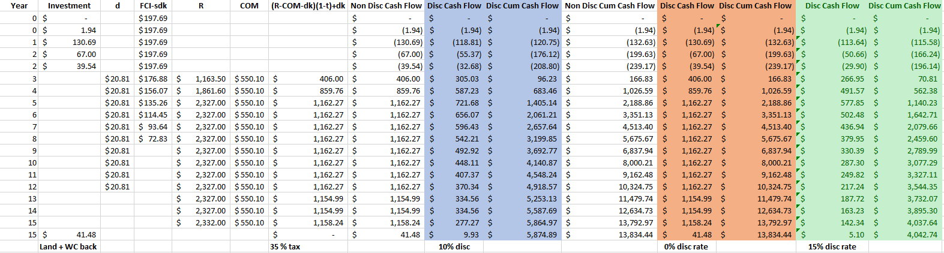

**Table 15.4** MACRS cash flow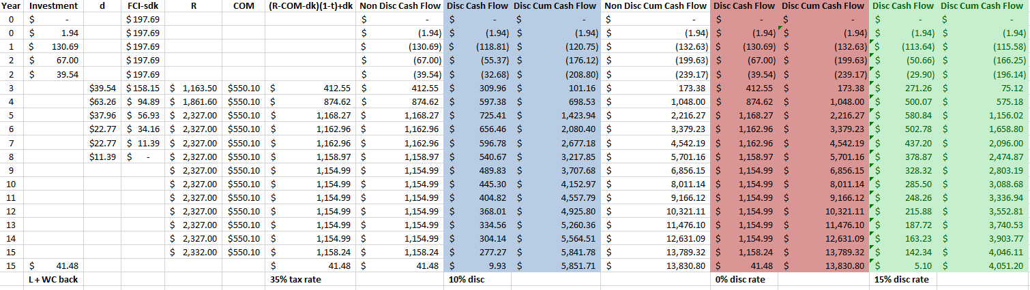

Tables 15.3 and 15.4 also includes multiple discounted cash flows. The differences between each cash flow are the discount rate. Discount rates of 0%, 10%, as well as 15% percent were calculated. When determining the cash flows, taxes were taken into consideration. Due to the plant being located in Texas the only tax to be taken away is at the federal level. Projected revenues have placed the process in the highest federal tax bracket which equates to a rate of 35%.

Another key finding in the cash flow tables includes how the first draws will be made. As seen in the investment column during year zero, the first draw will be for the plot of land. The second draw will be the largest equating to a total of 130.69 million USD. Based on the construction timeline, this sum will cover the majority of the work. Finally, in year two the last draw will be made. The last draw is projected to be 67.00 million USD. As mentioned earlier, working capital was also considered when determining profitability. The working capital can be seen in the investment column, totaling 39.54 million USD.

Two graphs were generating using the information in Tables 15.3 and 15.4. The graphs highlight each discount rate for a total project life of 15 years. Figure 15.1 displays the straight-line method while Figure 15.2 displays the MACRS method.

**Figure 15.1** Cash flow diagram using straight line depreciation

**Figure 15.2** Cash flow diagram using the MACRS method

As shown by the figures just presented, it is clear the plant is mostly in positive cash flow for nearly its entire lifespan. Each graph displays three different curves that correspond to their respective discount rates. The figures conclude the most profit will be with a 0% discount, followed by 10% and then finally 15%. It is difficult to determine exactly when the design will be profitable. Taking a closer look at figure 15.3 and 15.4 it is easy to determine that profitability will be reached shortly after the end of year two.

**Figure 15.3** Cash flow diagram showing profitability for straight line method

**Figure 15.4** Cash flow diagram showing profitability for MACRS method

The negative cash flows are clearly shown as they represent the investment made for this project. The first investment noted, is the land cost. Following the land cost investment for the construction of the plant was made. Year three, the first revenue generating year clearly makes the plant profitable about halfway through the year. For each discount rate, the profitability varies by only a few months. Analysis was performed to determine the amount of time it takes to recoup the FCI as well as the working capital. This is also known as the discounted payback period. As shown on the two figures just presented, the discounted payback period is found to be shortly after year two has ended for each discount rate. The entire investment will be recovered very quickly which makes the design favorable to be designed. Having a short payback period can lure outside investors if required for the plant construction.

Nearing the end of the project life, 15 years, it is imperative to determine the worth of the project. To determine the worth of the project, net present value (NPV) was used. NPV is the cumulative discounted cash position at the end of the project life. The NPV is shown on figure 15.1 and 15.2 at year 15. The figure displays the NPV for three separate discount rates. To be more specific table 15.5 was developed to better show the exact totals of the net present value of the project. The table displays net present values for each depreciation method, as well as each discount rate.

**Table 15.5** Net present value at the end of project life for each method

|  |  |  |
| --- | --- | --- |
| **Method** | **Discount Rate** | **NPV (millions)** |
| Straight Line | 0% | $13,834.44 |
|  | 10% | $5,874.89 |
|  | 15% | $4,042.74 |
| MACRS | 0% | $13,830.80 |
|  | 10% | $5,851.71 |
|  | 15% | $4,051.20 |

Furthermore, it is clear that the 0% discount rate holds the highest net present value while the 15% is the lowest amount. The net present value proves the plant is investable as it continues to gain value year after year. Not only does the plant gain value every year, but the final value is also substantial when compared to the TCI. The TCI is only a small fraction of what the plant will be worth in 15 years.

Another important economic value to analyze is the discounted cash flow rate of return on investment (DCFROR). This parameter is calculated from averaging the discounted annual net profit and dividing it by the FCI. For this analysis it is important to note that the calculation performed used results from the MACRS depreciation with a discount rate of 10%. Also, the numbers used are in millions of dollars.

DCFROR = $465.43/$197.69 = 235.43% (15.1)

The rate is very high which means the plant is producing a very good profit. More specifically the rate is high due to the large amount of revenue that is going to be generated by the selling of ethylene.

Establishing a full economic analysis proves this design is one to move forward with on its own. To be comparative, it is important to determine if the opportunity cost of investing in this design is not outweighed by simply investing the total capital investment in a regular fund. An assumption of return rate was made and concluded to be 10%. The investment will be thrown in all at once in year one. For accurate comparison the length of time will be equivalent to the project life, 15 years. Equation 15.2 displays the calculation that was performed. Where F, if the final value of the investment, P is the present investment, i is the interest rate, and n is length of investment. The present investment is represented by the TCI.

F = P *(1 + i)n  (15.2)

$1,144,331,592= $239,170,276.74* (1+.10)15 (15.3)

Determining this investment, it is clear that the plant design provides more financial success as the NPV of the plant is substantially larger when compared to the investment value of the investment. It is important to note that the regular fund investment does not consider annual inflation. Even without accounting for inflation, the plant designs returns are much greater.

Overall, the economic analysis of the plant has determined the design is worth moving forward with. The ethylene plant design proves profitability, and not just for a short period of time. The plant is producing a profit shortly after initial startup in year three. Although operating costs are a large sum of money, half- a billion dollars per year, the price of ethylene immensely outweighs this. Assessing the profitability, the values previously discussed are projected estimations and may not hold completely true. For this design things that were not considered in detail is how normal ethylene dehydration plants have an entire section just dedicated to handle the cryogenic properties of ethylene. The scope of this project allowed the design to not take that into consideration due to extreme complexities of the cryogenic systems. The “simplistic” process aided toward the design being highly profitable. Another note to add is that waste treatment and utilities cost may not be exactly accurate. It is difficult to determine the exact waste cost of our material due to lack of resources. Even though there are some discrepancies, this design can be fully functional and extremely profitable.

1. **Summary**

There are many things to be considered when developing a new ethylene plant. Instead of using the traditional method of steam cracking fossil fuels to produce ethylene, this plant used the dehydration of ethanol in an effort to be more environmentally friendly. By using the catalyst H-ZSM5, a higher selectivity of ethylene is able to be achieved. This plant would generate $2.327 billion in revenue each year, and it would control about 1% of the US Market. This is a very high net present value when compared to investment costs, indicating high profitability.

This ethylene plant should be able to produce 106,818 lb/hr of ethylene, and it is to be run 8000 hr/yr. The process ended up running two parallel reactors so that the equipment would not be oversized, and if one reactor were to fail the production would still be able to continue at reduced capacity. After only one year of operation, the plant should be able to make a profit with very little downtime and get a return on investment.

Due to the decision to use the dehydration of ethanol to make ethylene, carbon emissions would be minimized compared to the more traditional method of steam cracking fossil fuels, making this a more environmentally friendly process. While the process does produce diethyl ether, which can be hazardous, it is only present in very small amounts which will not be completely detrimental to the safety of the people and environment. Although there are fire hazards due to the presence of ethylene and ethanol, fires can be mitigated due to the layout of the plant, where these compounds are set far enough apart from each other.

The domestic location of the plant ended up being in San Antonio, Texas. Texas is one of the leading producers of ethylene, and San Antonio is the second most populated city in Texas, so finding commercial zoned land and having access to other chemical plants are very easy. The international location of the plant was selected to be in Panama, located in Central America. While land is cheaper in Panama, it is more difficult to find the appropriate land and resources to build the plant.

By constructing an ethylene plant in the previously mentioned locations, there are other considerations to be made regarding external influences. There is the possibility of an accident happening at the plant due to severe weather in both locations as well as the possibility of damaging the surrounding ecosystems. However, the plant would be able to stimulate international trade, allowing Panama to set foot in the chemical manufacturing industry and create more jobs in the area, thus growing the local economy and helping the environment by excluding fossil fuels from the process.

Overall, this ethylene plant is a very worthwhile project. It will be lucrative in a short amount of time, and it will also be more environmentally friendly when it comes to production. It will be very beneficial to not only the local, but also the global economy. There are more positives that outweigh the negatives when it comes to the development of the plant and its method of producing ethylene.

**16.0 References**

[1] “Ethylene Uses and Market Data.” *Trusted market intelligence for the global chemical,*  *energy and fertilizer industries,* [Online]. Available: https://www.icis.com/resources/news/2007/11/05/9075777/ethylene- uses-and-market-data/. Accessed: January 28, 2021

[2] “The Highest Volume Chemical Produced in the World Is . . .” *Chapelboro.com*, 8 Mar. 2016, chapelboro.com/town-square/columns/common-science/the-highest-volume-chemical-produced-in-the-world-is. Accessed: March 9, 2021

[3] “The 5 Most Common Plastics & Their Everyday Uses.” *Cut Plastic Sheeting*, 1 Feb. 2021, www.cutplasticsheeting.co.uk/the-5-most-common-plastics-their-everyday-uses/. Accessed: March 9, 2021

[4] “Ethylene Production and Manufacturing Process.” *ICIS Explore*, [Online]. Available: https://www.icis.com/explore/resources/news/2007/11/05/9075778/ethylene- production-and-manufacturing-process/. Accessed: January 28, 2021

[5] “Diethyl Ether,” *Fisher Science,* https://www.fishersci.com/us/en/browse/80014067/diethyl-ether. Accessed: March 3, 2021

[6] *Ethylene - Linde US*. www.lindeus.com/-/media/corporate/praxairus/documents/sds/ethylene-c2h4-safety-data-sheet-sds-p4598.pdf?la=en. Accessed: March 10, 2021

[7] M. Zhang and Y. Yu, “Dehydration of Ethanol to Ethylene,” Industrial & Engineering Chemistry Research, vol. 52, no. 28, pp. 9505–9514, Mar. 2013. Accessed: January 31, 2021

[8] G. Cameron and L. Le, “Process Design for the Production of Ethylene from Ethanol,”

*University of Pennsylvania Scholarly Commons, p. 1-115*, April 2012. [Online]. Available: https://repository.upenn.edu/cgi/viewcontent.cgi?referer=https://www.google.com/&httpsredir=1&article=1036&context=cbe_sdr. Accessed: January 31, 2021

[9] “Ethanol.” *National Center for Biotechnology Information. PubChem Compound Database*, U.S. National Library of Medicine, pubchem.ncbi.nlm.nih.gov/compound/ethanol#section=Taste. Accessed: March 6, 2021

[10] “Water.” *National Center for Biotechnology Information. PubChem Compound Database*, U.S. National Library of Medicine, pubchem.ncbi.nlm.nih.gov/compound/962#section=Interactions. Accessed: March 5, 2021

[11] “Ethylene.” *National Center for Biotechnology Information. PubChem Compound Database*, U.S. National Library of Medicine, pubchem.ncbi.nlm.nih.gov/compound/6325#section=Hazard-Classes-and-Categories. Accessed: March 7, 2021

[12] “Ether.” *National Center for Biotechnology Information. PubChem Compound Database*, U.S. National Library of Medicine, pubchem.ncbi.nlm.nih.gov/compound/3283. Accessed: March 8, 2021

[13] “Ethanol2005-2021 Data: 2022-2023 Forecast: Price: Quote: Chart: Historical.” *Ethanol | 2005-2021 Data | 2022-2023 Forecast | Price | Quote | Chart | Historical*, tradingeconomics.com/commodity/ethanol. March 1, 2021

[14] "Water & Wastewater Survey | Texas Municipal League, TX", *Tml.org*, 2021. [Online]. Available: https://www.tml.org/229/Water-Wastewater-Survey-Results#:~:text=to%20their%20residents.-,The%20average%20cost%20of%20water%20usage%20of%205%2C000%20gallons%20in,cities%20responding%20to%20the%20survey. Accessed: 02 Apr 2021

[15] "IDAAN WEB – Panamá", *Idaan.gob.pa*, 2021. [Online]. Available: https://www.idaan.gob.pa/. Accessed: 02 Apr 2021

[16] “Ethylene Market Size, Historical Growth, Analysis, Opportunities and Forecast To 2025.” *MarketWatch*, MarketWatch, 2 Feb. 2021, [Online]. www.marketwatch.com/press-release/ethylene-market-size-historical-growth-analysis-opportunities-and-forecast-to-2025-2021-02-02. Accessed: February 8, 2021

[17] “Ethylene Market: Extensive Use of Polyethylene in Making Packaging Products to Bolster Uptake, notes TMR,” *Transparency Market Research,* July 20, 2017. [Online]. Available: https://www.transparencymarketresearch.com/pressrelease/ethylene-market.htm. Accessed: February 2, 2021

[18] “High Purity Ethylene.” *High Purity Ethylene Gas C2h4 99.5% With Cylinder Price - Buy Ethylene Gas,C2h4 Gas,C2h4 99.5% Product on Alibaba.com*, www.alibaba.com/product-detail/High-Purity-ethylene-gas-C2H4-99_1600206070765.html?spm=a2700.galleryofferlist.normal_offer.d_title.6f6f5504ugM4iy. Accessed: March 9, 2021

[19] "Compressed Air Basics", *Aiche.org*, 2021. [Online]. Available: https://www.aiche.org/resources/publications/cep/2017/may/compressed-air-basics. Accessed: 02 Apr 2021.

[20] “Standard State and Enthalpy of Formation, Gibbs Free Energy of Formation, Entropy and Heat Capacity.” *Engineering ToolBox*, [Online]. www.engineeringtoolbox.com/standard-state-enthalpy-formation-definition-value-Gibbs-free-energy-entropy-molar-heat-capacity-d_1978.html. Accessed: February 9, 2021

[21] “Liquids - Specific Gravities.” *Engineering ToolBox,* [Online]. www.engineeringtoolbox.com/specific-gravity-liquids-d_336.html. Accessed: February 9, 2021

[22] "Boiling Points for common Liquids and Gases", *Engineeringtoolbox.com*, 2021. [Online]. https://www.engineeringtoolbox.com/boiling-points-fluids-gases-d_155.html. Accessed: February 9, 2021

[23] "Freezing and Melting Points for common Liquids", *Engineeringtoolbox.com*, 2021. [Online]. https://www.engineeringtoolbox.com/freezing-points-liquids-d_1261.html. Accessed: February 10, 2021

[24] Matsoukas, Themis. “Fundamentals of Chemical Engineering Thermodynamics.” *O'Reilly Online Learning*, Pearson, [Online]. www.oreilly.com/library/view/fundamentals-of-chemical/9780132693158/app02.html. Accessed: February 10, 2021

[25]“Safety & Health Guide for the Chemical Industry,” www.osha.gov/archive/Publications/osha3091.html. Accessed: March 11, 2021

[26] "Texas Health and Safety Code § 382.05198 | FindLaw", *Findlaw*, 2021. [Online]. Available: https://codes.findlaw.com/tx/health-and-safety-code/health-safety-sect-382-05198.html. Accessed: 02 Apr 2021.

[27] "Which states/provinces export ? (2020) | OEC - The Observatory of Economic Complexity", *Oec.world*, 2021. [Online]. Available: https://oec.world/en/visualize/tree_map/subnational_usa/export/show/all/5271114/2020/. Accessed: 06 Apr 2021.

[28] *Scribd.com*, 2021. [Online]. Available: https://www.scribd.com/document/435031380/International-Law. Accessed: 06 Apr 2021.

[29] "Where does export to? (2019) | OEC - The Observatory of Economic Complexity", *Oec.world*, 2021. [Online]. Available: https://oec.world/en/visualize/tree_map/hs92/export/pan/all/5271114/2019/. Accessed: 02 Apr 2021.

[30] "To make better decisions, you need to see the big picture.", *IHS Markit*, 2021. [Online]. Available: https://ihsmarkit.com/products/ethylene-chemical-economics-handbook.html#:~:text=Ethylene%20is%20primarily%20a%20petrochemically,other%20industrial%20and%20consumer%20markets. Accessed: 02 Apr 2021.

[31] "Think Hazard - Panama - Earthquake", *Thinkhazard.org*, 2021. [Online]. Available: https://thinkhazard.org/en/report/191-panama/EQ. Accessed: 02 Apr 2021.

[32] E. Douglas, "Texas plants released nearly as much pollution during winter storm as during Hurricane Laura", *The Texas Tribune*, 2021. [Online]. Available: https://www.texastribune.org/2021/02/24/texas-winter-storm-pollution-emissions/. Accessed: 02 Apr 2021.

[33] H. Canada, "Environment and Climate Change Canada", 2021. [Online]. Available: https://www.ec.gc.ca/ese-ees/default.asp?lang=En&n=0C828850-1#toc7. Accessed: 02 Apr 2021.

[34] Araki, Yuko, et al. "Explosion at an aluminum factory caused by the July 2018 Japan floods: Investigation of damages and evacuation activities." *Journal of Loss Prevention in the Process Industries* 69 (2021): 104352.

[35] UNICEF. *The state of the world's children 2007: women and children: the double dividend of gender equality*. Vol. 7. Unicef, 2006.

[36] Bakari, Sayef, and Mohamed Mabrouki. "Impact of exports and imports on economic growth: new evidence from Panama." *Journal of Smart Economic Growth* 2.1 (2017): 67-79.

[41] "Texas Administrative Code", 2021. [Online]. Available: https://texreg.sos.state.tx.us/public/readtac$ext.ViewTAC?tac_view=5&ti=30&pt=1&ch=335&sch=T&rl=Y. Accessed: 02 Apr 2021.

[42] "The Law Reviews - The Environment and Climate Change Law Review", *Thelawreviews.co.uk*, 2021. [Online]. Available: https://thelawreviews.co.uk/title/the-environment-and-climate-change-law-review/panama. Accessed: 02 Apr 2021.

[39]"The Law Reviews - The Environment and Climate Change Law Review", *Thelawreviews.co.uk*, 2021. [Online]. Available: https://thelawreviews.co.uk/title/the-environment-and-climate-change-law-review/panama. Accessed: 02 Apr 2021.

[40] J. Garc´ıa-Serna, L. Perez-Barrig ´ on, and M. J. Cocero, “New trends for design towards sustainability in chemical engineering: Green engineering,” *Chemical Engineering Journal*, vol. 133. 30-Jul-2007.

[41] C. Benson, R. Wilson, J. Jamaluddin, S. Marty, and T. Young, “Fuel-Flexible Combustion System for Refinery and Chemical Plant Process Heaters.” 15-Jul-2014.

[42] “Basic Information about Landfill Gas,” *EPA*, 16-Apr-2021. [Online]. Available: https://www.epa.gov/lmop/basic-information-about-landfill-gas. [Accessed: 28-Apr-2021].

[43] “Industrial Process Heating - Technology Assessment,” *Energy Information Administration*. [Online]. Available: https://www.energy.gov/sites/default/files/2015/02/f19/QTR%20Ch8%20-%20Process%20Heating%20TA%20Feb-13-2015.pdf.

[44] J.-Y. Choi and S.-H. Byeon, “Case Study: Safety Assessment of Plant Layout between Ethylene Storage Tanks and Process Equipment According to Capacity and Weather Conditions,” *International Journal of Environmental Research and Public Health*, vol. 17, no. 8. https://www.ncbi.nlm.nih.gov/pmc/articles/PMC7216264/pdf/ijerph-17-02849.pdf. Accessed: 28 Apr 2021.

[45] “Texas Health and Safety Code - HEALTH & SAFETY § 382.05198,” *Findlaw*. [Online]. Available: https://codes.findlaw.com/tx/health-and-safety-code/health-safety-sect-382-05198.html. Accessed: 28 Apr 2021.

[46] “+/- 226 Acres Applewhite Rd, Bexar County,” *Loopnet.* [Online]. Available: https://images1.loopnet.com/d2/DBOBi9C-9HWbalWw9Zkul_gbFLgAd8xa2V7tkjB0O68/Applewhite%20Flyer.pdf. Accessed: 21 Apr 2021.

[47] “Summary of the Clean Air Act,” *EPA*, 06-Aug-2020. [Online]. Available: https://www.epa.gov/laws-regulations/summary-clean-air-act. Accessed: 28 Apr 2021.

[48] https://www.sanantonio.gov/Portals/0/Files/health/HealthyEnvironment/Ordinance2015-11-19-0967AirPollution.pdf

[49] *Texas Administrative Code*. [Online]. Available: https://texreg.sos.state.tx.us/public/readtac$ext.TacPage?sl=T&app=9&p_dir=P&p_rloc=72298&p_tloc=&p_ploc=1&pg=9&p_tac=&ti=30&pt=1&ch=101&rl=1. Accessed: 28Apr 2021.

[50] “About NPDES,” *EPA*, 04-Jun-2020. [Online]. Available: https://www.epa.gov/npdes/about-npdes. [Accessed: 28-Apr-2021].

[51] “Industrial Wastewater Discharges: The Permit Process,” *Texas Commission on Environmental Quality*. [Online]. Available: https://www.tceq.texas.gov/permitting/wastewater/industrial/TPDES_industrial_wastewater_steps.html. Accessed: 28 Apr 2021.

[52] Enick, Robert. *Dr. Enick’s New Compressor Slides.*.PowerPoint Presentation.

[53] “Agricultural Farm Tonosi Valley, Azuero Peninsula,” *Panama Realtor*. [Online]. Available: https://www.panamarealtor.com/property/4685. Accessed: 28 Apr 2021.

[54] R. K. L. Morales and H. Alvarez, "Operation feasible region for flash distillation control and design," 2017 IEEE 3rd Colombian Conference on Automatic Control (CCAC), 2017, pp. 1-6, doi: 10.1109/CCAC.2017.8276405.

**Appendix 1 – Reaction Schemes**

Reaction 1:

Ethanol $↔$ Water + Ethylene

$$C_{2}H_{5}OH↔H_{2}O+C_{2}H_{4}$$

Reaction 2:

2 Ethanol $→$ Water + Diethyl-Ether

$$2C_{2}H_{5}OH → H_{2}O+{(C_{2}H_{5})}_{2}O$$

**Appendix 2- Sample Calculations**

**2.1 Mass Balance Sample Calculation**

$$S_{Ethylene,R101}= \frac{\dot{n} {EtOH}_{consumed by ethylene reaction}}{\dot{n} {EtOH}_{consumed overall}} ×100\%= \frac{1904.963 kmol/hr}{1907.218 kmol/hr} ×100\%= 99.88\%$$

**2.2 Heat Flow Sample Calculation**

Heat Flow Sample Calculation

For Stream 1

+ VΔP

Hf, Ethanol = -100800 BTU/lbmol

Hf, Water = -104200 BTU/lbmol

VS102 = 6.99e+06 in3/hr

Patm = 14.69 psi

Ethanol(lbmol/hr) = 4219.4757

Water(lbmol/hr) = 567.901526

Using heat capacity constants A,B,C, and D from Table 9.2

Tref = 25 °C = 298.15 K = 757.8 °R

Operating Pressure = 630 psi

Operating Temp (T) = 77 F = 350.15 K

Heat Flow = (-100800 BTU/lbmol * 4219.4757 lbmol(ethanol)/hr + -104200 BTU/lbmol * 567.901526 lbmol(water)/hr) + $1.986 BTU/lbmol°R\int_{757.8}^{809.8}{4.396+0.628*{10}^{-3}T+5.546*{10}^{-5}T^{2}-7.024*{10}^{-8}T^{3}dt}$* 4219.4757 lbmol(ethanol)/hr + $1.986 BTU/lbmol°R\int_{757.8}^{809.8}{4.395+4.186{*10}^{-3}T+1.405*{10}^{-5}T^{2}-1.56*{10}^{-8}T^{3}dt}$* 567.901526 lbmol(water)/hr + (6.99e+06 in3/hr)(630 psi – 14.69 psi)

Heat Flow = -5.73 * 108 BTU/hr

**Appendix 3- Equipment Data Sheets**

**3.1** Heat exchanger HX101 Data Sheet

|  |  |  |
| --- | --- | --- |
| Heat Exchanger | | |
| Identification Item: Heat Exchanger |  |  |
| Item Labels: HX101 |  |  |
| Quantity: 1 |  |  |
| Function: To transfer heat away from products stream |  |  |
| Type: 1:1 Shell and Tube |  |  |
| Materials Handled: Ethanol, Water, Diethyl ether, Ethylene | Inlet | Outlet |
|  | 9 | 10 |
| Mass Flow(lb/hr): | 96845 | 96845 |
| Molar Flow(lbmol/hr): | 8596.592 | 8596.592 |
| Component Flow(lbmol/hr): |  | |
| Ethanol | 401.88 | 401.88 |
| Water | 4364.27 | 4364.27 |
| Diethyl Ether | 45.32 | 45.32 |
| Ethylene | 3785.13 | 3785.13 |
| Temperature(°F) | 624 | 212 |
| Pressure(Psi) | 653 | 643 |
| Design Data: |  | |
| Heat Transfer Area(ft^2) | 1842.7 | |
| Tube design gauge pressure(psig) | 720 | |
| Tube design temperature(°F) | 690 | |
| Tube operating temperature(°F) | 624 | |
| Tube outside diameter(in.) | 0.75 | |
| Shell design gauge pressure | 500 | |
| Shell design temperature | 370 | |
| Shell operating temperature | 300 | |
| Tube pitch(ft) | 0.9375 | |
| Tube length(in.) | 240 | |
| Tube Number | 480 | |
| Number of tube passes | 1 | |
| Number of shell passes | 1 | |
| Baffle Spacing(in.) | 19.75 | |
| Shell Inner Diameter(in.) | 24 | |
| Shell Outer Diameter(in.) | 24.75 | |
| Number of Baffles | 10 | |
| Cost(USD): |  | |
| Equipment | $51,443.00 | |
| Installation(Labor Cost) | $97,484.00 | |
| Utilities(USD/hr) | $90.97 | |

**3.2** Heat exchanger HX102 Data Sheet

|  |  |  |
| --- | --- | --- |
| Heat Exchanger | | |
| Identification Item: Heat Exchanger | | |
| Item Labels: HX102 | | |
| Quantity: 1 | | |
| Function: To transfer heat away from products stream |  |  |
| Type: 1:1 Shell and Tube |  |  |
| Materials Handled: Ethanol, Freon, Diethyl ether, Ethylene | Inlet | Outlet |
|  | 13 | 14 |
| Mass Flow(lb/hr): | 120131.8 | 120131.8 |
| Molar Flow(lbmol/hr): | 3443 | 3443 |
| Component Flow(lbmol/hr): |  | |
| Ethanol | 68.25 | 68.25 |
| Water | 132.68 | 132.68 |
| Diethyl Ether | 7.26 | 7.26 |
| Ethylene | 3235.67 | 3235.67 |
| Temperature(°F) | 282.77 | 32 |
| Pressure(Psi) | 507.632 | 497.642 |
| Design Data: |  | |
| Heat Transfer Area(ft^2) | 2129.2 | |
| Tube design gauge pressure(psig) | 560 | |
| Tube design temperatue(°F) | 350 | |
| Tube operating temperature(°F) | 282.77 | |
| Tube outside diameter(in) | 0.75 | |
| Shell design gauge pressure | 600 | |
| Shell design temperature | 100 | |
| Shell operating temperature | 20 | |
| Tube pitch(ft) | 0.9375 | |
| Tube length(ft) | 216 | |
| Tube Number | 616 | |
| Number of tube passes | 4 | |
| Number of shell passes | 1 | |
| Baffle Spacing | 14.25 | |
| Shell Inner Diameter(in) | 28 | |
| Sheel Outer Diameter(in.) | 29.125 | |
| Number of Baffles | 14 | |
| Cost(USD): |  | |
| Equipment | $18,752.00 | |
| Installation(Labor Cost) | $40,981.00 | |
| Utilities(USD/hr) | $31.97 | |

**3.3** Flash Tank V201 Data Sheet



**3.4** Flash Tank V202 Data Sheet



**3.5** Compressor C201 Data Sheet



**3.6** Compressor C102 Data Sheet



**3.7** Fired Heater F101 Data Sheet



**3.8.1** Reactor R101 Data Sheet



**3.8.2** Reactor R102 Data Sheet



**3.9.1** Distillation Column Equipment Data Sheet T201

|  |  |  |  |
| --- | --- | --- | --- |
| **Distillation Column** |  |  |  |
| **Identification Item: Distillation Column** |  |  |  |
| **Quantity: T201** |  |  |  |
| **Function: Separate Ethylene from Waste Stream into Recovery Stream** |  |  |  |
| **Materials Handled: Ethanol, Water, Diethyl Ether, Water** | **Inlet** | **Top Outlet** | **Bottoms Outlet** |
|  | **18** | **20** | **19** |
| **Mass Flow (lb/hr):** | **121549** | **21684** | **99868** |
| **Ethanol (lb/hr)** | **18474** | **418** | **18056** |
| **Water (lb/hr)** | **78615** | **89** | **78526** |
| **Diethyl ether (lb/hr)** | **3294** | **545** | **2750** |
| **Ethylene (lb/hr)** | **21165** | **536** | **536** |
| **Temperature (°F)** | **201** | **0** | **159** |
| **Pressure (Psi)** | **322** | **15** | **15** |
| **Molar Flow (lbmol/hr):** | **5564** | **757** | **4807** |
| **Design Data:** |  |  |  |
| **Material of Construction** |  |  | **Stainless Steel 304** |
| **Diameter (ft)** |  |  | **4** |
| **Height (ft)** |  |  | **14** |
| **Installed Weight (lbs)** |  |  | **53,762** |
| **Tray Size (ft)** |  |  | **2.4** |
| **Number of Stages** |  |  | **6** |
| **Tray Type** |  |  | **Bubble Cap** |
| **Space Between Trays (ft)** |  |  | **2** |
| **Cost:** |  |  |  |
| **Equipment Cost:** |  |  | **$92,800.00** |
| **Installation Cost:** |  |  | **$467,300.00** |

**3.9.2** Distillation Column Equipment Data Sheet T202

|  |  |  |  |
| --- | --- | --- | --- |
| **Distillation Column** |  |  |  |
| **Identification Item: Distillation Column** |  |  |  |
| **Quantity: T202** |  |  |  |
| **Function: Purify Ethanol and Water Stream Before Entering Recovery System** |  |  |  |
| **Materials Handled: Ethanol, Water, Diethyl Ether, Water** | **Inlet** | **Top Outlet** | **Bottoms Outlet** |
|  | **19** | **22** | **21** |
| **Mass Flow (lb/hr):** | **99868** | **18094** | **81774** |
| **Ethanol (lb/hr)** | **18055** | **13613** | **13613** |
| **Water (lb/hr)** | **78525** | **1199** | **1200** |
| **Diethyl ether (lb/hr)** | **2749** | **2745** | **536** |
| **Ethylene (lb/hr)** | **536** | **536** | **2745** |
| **Temperature (°F)** | **159** | **0** | **202** |
| **Pressure (Psi)** | **15** | **15** | **15** |
| **Molar Flow (lbmol/hr):** | **4807** | **418** | **1388** |
| **Design Data:** |  |  |  |
| **Material of Construction** |  |  | **Stainless Steel 304** |
| **Diameter (ft)** |  |  | **8.5** |
| **Height (ft)** |  |  | **36** |
| **Installed Weight (lbs)** |  |  | **252,041** |
| **Tray Size (ft)** |  |  | **2.4** |
| **Number of Stages** |  |  | **17** |
| **Tray Type** |  |  | **Sieve** |
| **Space Between Trays (ft)** |  |  | **2** |
| **Cost:** |  |  |  |
| **Equipment Cost:** |  |  | **$458,200.00** |
| **Installation Cost:** |  |  | **$1,151,800.00** |